Name: ____________Date: ______

The Electromagnetic Spectrum- Limits of light video questions

Please complete the following questions on a separate piece of paper. Remember that these are critical thinking questions, and require full sentences and paragraphs to answer completely. Note: the video can be found on the class blog.

- What part of the wave gives light its colour?
- a.. Who discovered that white light was made up of different colours?
b. Describe the experiment he used to prove this.
- What are pigments? How do they work?
- Why are leaves green?
- Why is the sky blue?
- What were some uses of the colour indigo?
- Name an animal that can see UV. How do they use this adaptation?
- What was the first X-ray of?
- What can cause bursts of gamma rays? (at 29:09 of video)
- In nature what do the colours orange and red signify?

*Once you have finished your work, be sure to fill in the rubric below to show what you feel you have earned with the quality of your answers.
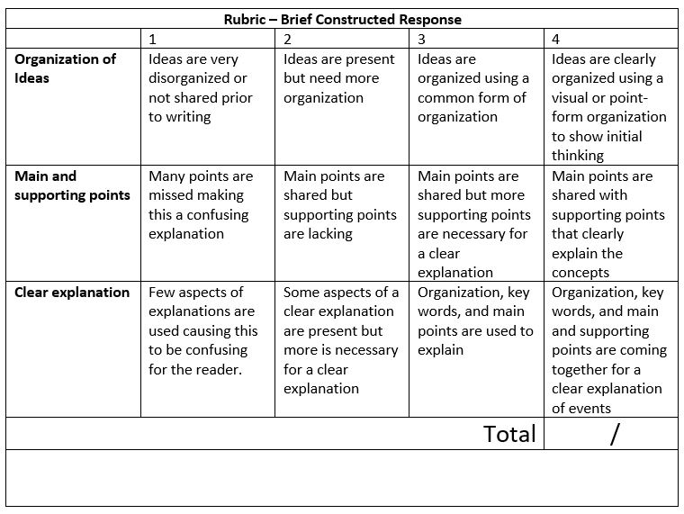

- How were infrared rays discovered?
(infrared rays have longer wavelengths than red light) William Herschel (1800) was measuring the temperature of different colours of light and he noticed that a thermometer in a dark area (below red) was warmer than the other colours.

- What is one application of infrared light?
Infrared photography. These types of cameras can pick up reflected (or emitted) infrared light.

- Which parts of the body radiate the most heat?
Far infrared waves indicate the temperature of an object. Your head radiates the most heat.

- What is one application of microwaves?
(microwaves have longer wavelengths than IR) Heating food.

- What are quasars and how were they discovered?
(radio waves have longer wavelengths than microwaves) A special type of galaxy that is 12 billion light years away that emit radio waves from a super-massive black hole at the centre of the quasar.

https://www.youtube.com/watch?v=jnGTCaiZqOE

