Pecha Kucha – The Presentation of Telling Your Story
Hey we are beginning our work on Pecha Kucha: the presentation art form of telling your story about any given topic. The first thing to remember is that Pecha Kucha is your story which makes it unique to you. You can present it on almost any topic of your choosing, however, the focus must be that it is on your story.
The first place to stop is the class blog where you will find videos that describe what pecha kucha is. Follow this link to begin.
As a class we watched the videos while taking some brief notes so that we could remember some of the main points of what pechakucha is. We reviewed the notes that Mr Ewert took (which were different than the notes of the students of course) and then students began working on their project.
Stages of the project:
Stage 1 (by Thurs., June 2 3:30):
- Choose your topic
  - What is the story?
    - Topic and finding where/who you are within it
    - What is the BIG IDEA (the theme of your story)
      - What are we walking away with having felt, learned, and now value
  - Remember that your big ideas are scattered throughout your presentation and the remaining steps are walking us there.

Stage 2 (by Tuesday, June 7, 3:30):
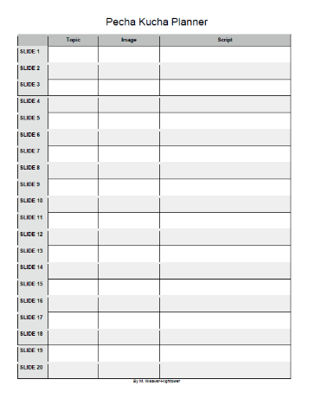
- Now that your big ideas (the main focus of your story) are set…
  - Find all the steps between the that take us through your story
- Start getting all your point form notes on what you will say
  - Remember that you are not typing up a prez, you are planning an outline to follow
  - Use your planner for this
- You might start finding slides at this point
  - Each picture represents one idea of your story
Stage 3 (by Wednesday, June 8, 3:30):
- Get all your slides ready
- start practicing your timing and delivery for each slide
  - put your pics into the template that Mr. Ewert posted on the blog
  - practice with the pre-timed slides
    - you might need to stretch some ideas into 2 slides and combine some ideas into one
- review the notes you took from the videos (are you following the advice given?)
Stage 4 (by Friday, June 9, 3:30)
- Today you are practicing your presentation in front of your peers. You will be in a small group and working on two key area…
  - 1) having the slides running on auto-pilot
  - 2) being able to present within that time frame and without reading a script
- You will be working with your partners and filling out feedback forms for each other (see rubric)
- Note: some students have asked if they can pre-record their presentations. If you are choosing that option then you will need a recording ready for this day to show your group and get feedback on. Also, if you notice in the rubric, eye contact is key. In your video you must be present on camera and looking at your audience (camera).
Stage 5 (by Tuesday, June 14, 3:30)
- You will once again be meeting with a group of peers to gain show your progress from your first feedback session. You will start by sharing the strengths and weaknesses of your first presentation and use phrases like, “I would like to watch for…” to ask your peers to give you particular feedback on what you have put some work into to improve.
Pecha Kucha Feedback
 | 1 | 2 | 3 | 4
Structure | Little evidence that the student carefully considered their presentation structure | Student has structured their presentation for with some evidence of how to share their story | Student has structured their presentation for with fair evidence of considering proper steps to sharing their story well | Student has structured their presentation for with clear evidence of considering proper steps to sharing their story with emphasis
Eye contact | Very poor eye contact | Needs to look at the audience more | Most of the time is looking at audience | Lots of eye contact with the audience
Tone and clarity | Tone and speed are problematic for the presentation | Needs more clarity and variation to draw in the audience | Clear tone with some variation of speed changes that help the presentation | Clear and expressive tone. Student varies the speed and tone of their voice for emphasis
Timing | Students is greatly struggling with the timing of the slides | Student is struggling to time the slides and needs more preparation and consideration | Students is timing slides adequately showing some practice and preparation for good timing | Student is timing the slides very well indicating a great level of practice to prepare
Overall | The Pecha Kucha is not working well as a story. It may be presenting in “bits and pieces” that need better flow. Much more preparation is necessary. | The Pecha Kucha tells some of a story but may need greater focus. More preparation and consideration of the audience is necessary. | The Pecha Kucha tells a story that engages at times, has evidence of building points, and shows that the audience was considered reasonably well when preparing for the project | The Pecha Kucha tells a story that is engaging for the audience with points of emphasis, building ideas, and clear evidence of a great deal of preparation
Total |  |  |  | /20

