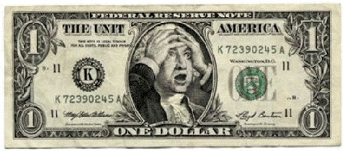
Find or Create Satire Assignment
In this assignment you will be either finding an example of satire to unpack and explain or creating an original piece of satire which you will unpack and then explain. Please refer to the PowerPoint presentation attached to the assignment for further information period when you have completed your assignment please fill out the rubric below, attach comma and hand in to ELA
Find or Create Satire Assignment Rubric
 |  | 1 | 2 | 3 | 4
Writing | Mechanics
 | Flow, Voice etc.
Critical Thinking | Accurately identifies reversal, incongruity, and/or exaggeration
 | Very clearly explains reversal, incongruity, and/or exaggeration
Total |  | /12
Notes:

Find or Create Satire Assignment
In this assignment you will be either finding an example of satire to unpack and explain or creating an original piece of satire which you will unpack and then explain. Please refer to the PowerPoint presentation attached to the assignment for further information period when you have completed your assignment please fill out the rubric below, attach comma and hand in to ELA
Find or Create Satire Assignment Rubric
 |  | 1 | 2 | 3 | 4
Writing | Mechanics
 | Flow, Voice etc.
Critical Thinking | Accurately identifies reversal, incongruity, and/or exaggeration
 | Very clearly explains reversal, incongruity, and/or exaggeration
Total |  | /12
Notes:

