Structure Building Challenge Lab – Paper Clips and Straws
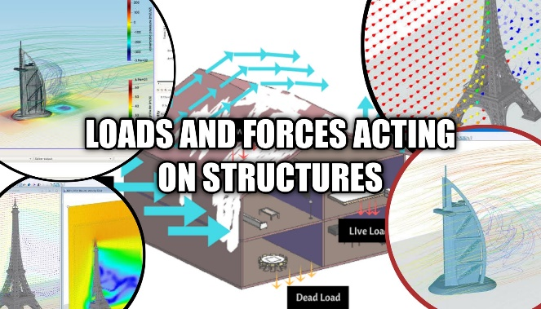
* day students will be designing, predicting, building, and reflecting up on how to build a stro ng structure using only straws and paperclips. Students will be challenged to build a structure that is a minimum of 10 centimeters in height, is constructed only of a maximum of 15 straws and 10 paperclips, and is able to hold a “load”. the load will be a paper plate with weights added to the top. Groups will continue to load weights onto the top of the structure until is structure experiences structural fatigue and structural failure. The challenge will be done in a formal lab template. Students are reminded to use the template provided to them at the beginning of the year, and may also access a copy online if they have lost theirs.
Step 1 - Complete the initial portions of your formal lab including the problem and materials
Step 2 - Get together with your small group where you will have 10 minutes to discuss a plan for building your structure.
Step 3 - Complete the procedure and hypothesis section of your formal lab including a detailed diagram of the design your group plans to create, and also, a detailed scientific explanation of your prediction of what will happen with your structure including the strengths and potential weaknesses that you predict.
Step 4 – You will have 18 minutes (just like the Marshmallow Challenge) for your group to build the structure.
Step 5 – Testing the structure – using a paper plate and the weights provided adding one at a time until structural fatigue and failure. Your structure must hold the weight for a total of 10 sec. without fatigue to be “successful”.
Step 6 – Complete your lab – make sure to have a complete scientific explanation of your results using all available vocabulary we have studied for this unit. Be sure to check your conclusion section on you science lab template to be sure you have all the parts asked for.
Vocabulary to remember/include:
