Jay Ewert
Sept. 22
Sci.
Mr. Ewert
Particle Theory of Matter Notes – the parts that matter
- Matter
  - Anything – weight and takes space
  - Volume
    - Fills an area
  - States
    - Solid
    - Liquid
    - Gas – eg: air
      - Can’t see it but…
        - Takes up space – eg: air fills balloon
        - Weight – full balloon weighs more than empty
- Particle Theory
  - Everything is made of matter – what is matter made of?
    - Particles
  - Solids
    - Made of part. – def. shape
  - Liquid
    - Made of part. – indef. Shape
      - Particles move around
  - Gas
    - Particles – lots of space that move around
  - Change of states of matter
    - Particles move around – can change state
  - Particles – what are they?
    - Atoms or molecules (groups of)
      - Atoms – basic elements
        - Eg: helium, hydrogen, oxygen
        - 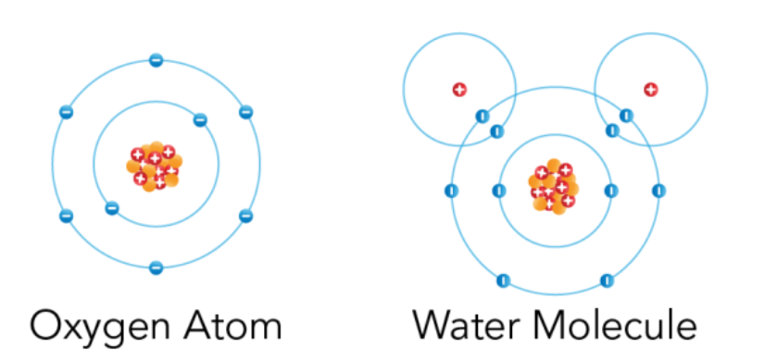
        - Made of protons, neutrons, electrons
      - Molecules
        - Atoms working together – eg: water
        - Atoms are attracted to each other
        - how close mol. Are means – solid, liq. – or gas
        - 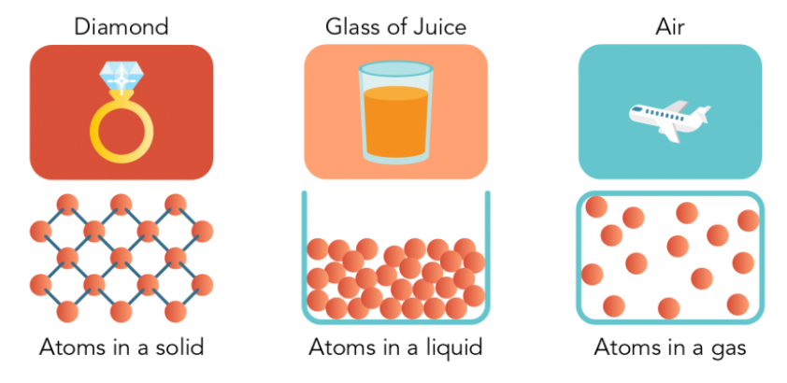
        - How fast mol. Move + their temp.
          - Faster = hotter and vice versa

