Intro to Properties of Fluids

- Prior to reading anything; what is a fluid in your opinion (what are the properties, examples, etc. )
- Share a definition of “matter”.
- What are the 3 states of matter?
- Draw a few diagrams that show the difference between a solid, a liquid, and a gas.

- 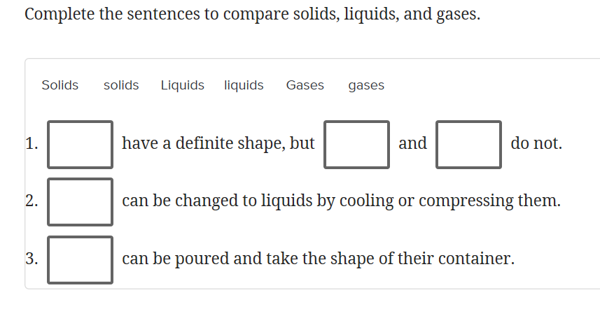
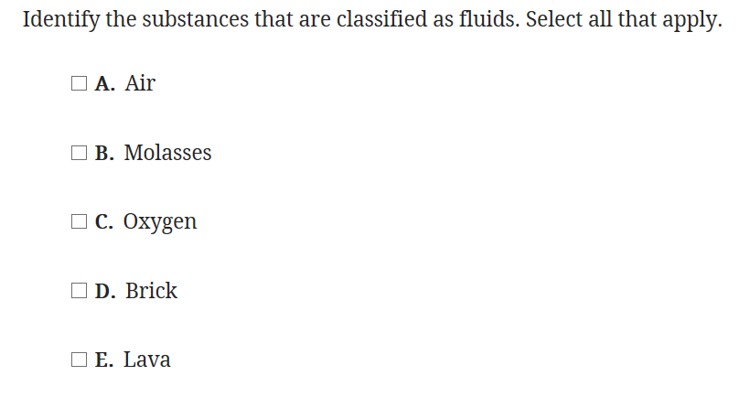

- now that you have spent some time identifying what a fluid is, create your own definition of what is a fluid period to define this you will need to use some examples in very particular words. You may want to refer to some of the vocabulary you studied on quizlet to help you.

Rubric – Brief Constructed Response
 | 1 | 2 | 3 | 4
Organization of Ideas | Ideas are very disorganized or not shared prior to writing | Ideas are present but need more organization | Ideas are organized using a common form of organization | Ideas are clearly organized using a visual or point-form organization to show initial thinking
Main and supporting points | Many points are missed making this a confusing explanation | Main points are shared but supporting points are lacking | Main points are shared but more supporting points are necessary for a clear explanation | Main points are shared with supporting points that clearly explain the concepts
Clear explanation | Few aspects of explanations are used causing this to be confusing for the reader. | Some aspects of a clear explanation are present but more is necessary for a clear explanation | Organization, key words, and main points are used to explain | Organization, key words, and main and supporting points are coming together for a clear explanation of events
Total |  |  |  | /

