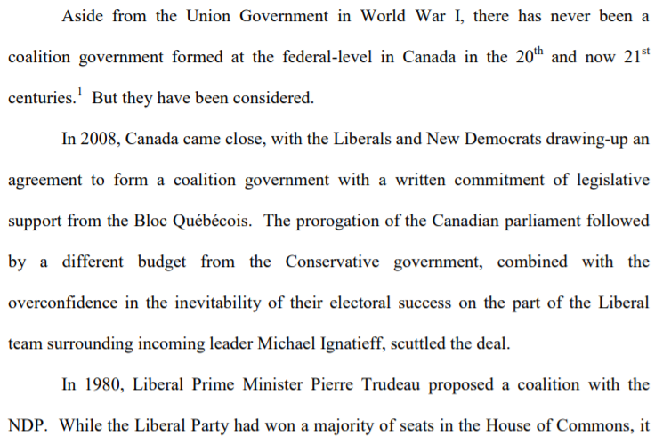 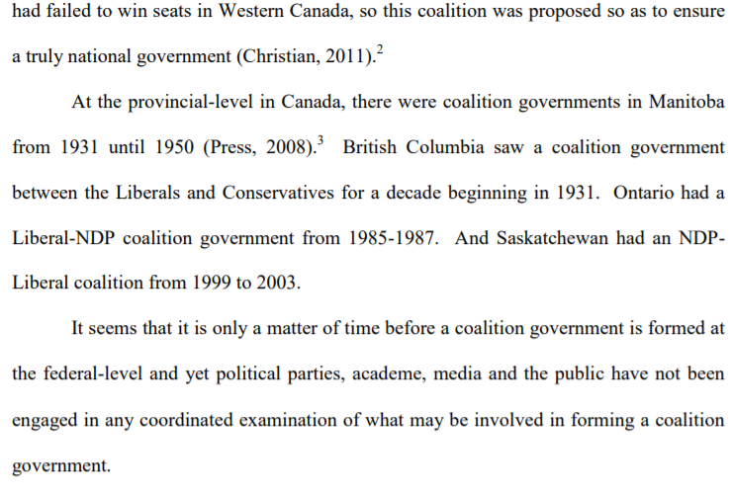Now that you have read the information about coalition governments you are to answer the following questions.

True/False
- __________ - There has only been one official coalition government at the federal level in Canada.
- __________ - in 2008 there was a coalition government formed.
- __________ - the only province in Western Canada to never have a coalition govenrment is Manitoba
- __________ - a minority government is one where the winning party is mostly made up of mp’s that are considered part of a cultural minority
- __________ - Justin Trudeau proposed a coalition with the NDP in 1980.

Fill-in-the-blanks
- In 2008 the ______________ and ________________ drew up an agreement for a coalition government.
- Recently in the news it was announced that ___________________ of the ________________ party said he would absolutely consider a coalition government with the ____________________ if the torries (Conservative party) were to win a minority government.

