Is Binge Watching Good For You? – Ted Talk via Asap Science
*Fill out your answers to the following questions below.
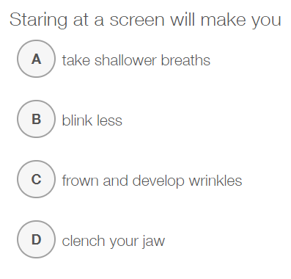
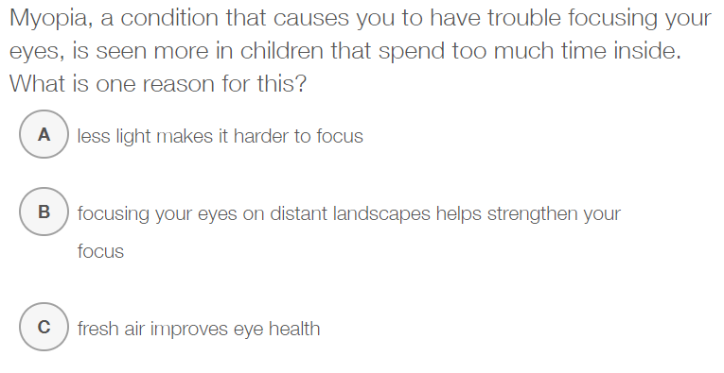

People who watch less TV burn more calories, even if they're just reading a book. Why?
_______________________________________________________________________________________________________________________________________________________________________________________________________________________________________________________________________________________________________________________________________________
Respond to one of the two questions below:
What was the most surprising thing you learned from this video?
What are some things you would want to do if you watched less TV?
_______________________________________________________________________________________________________________________________________________________________________________________________________________________________________________________________________________________________________________________________________________
_______________________________________________________________________________________________________________________________________________________________________________________________________________________________________________________________________________________________________________________________________________

