Mythbusters – The Death Ray
- Watch the first section of the show (0:00 – 6:45).
  - What do you think of the story of the death ray so far? (plausible or busted?)
  - What do you already know about light that might become important in this experiment?
- Watch the second section of the show (15:50 – 21:47)
  - What are some things the mythbusters have said that sound like smart ideas about the science of light (anything you wouldn’t have thought of?)
  - What are the key questions the mythbusters are trying to answer?
  - What do you think now (plausible or busted)
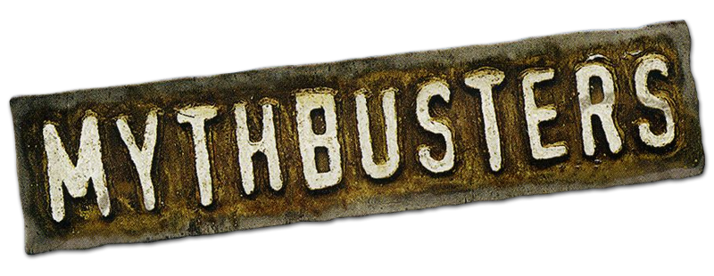
- Watch the final portion of the show (36:40 – 44:00 (the end))
  - What did they do well and what could they have done better?
  - Do you think it is busted or not (did they reasonably prove their theories?)

Mythbusters – The Death Ray
- Watch the first section of the show (0:00 – 6:45).
  - What do you think of the story of the death ray so far? (plausible or busted?)
  - What do you already know about light that might become important in this experiment?
- Watch the second section of the show (15:50 – 21:47)
  - What are some things the mythbusters have said that sound like smart ideas about the science of light (anything you wouldn’t have thought of?)
  - What are the key questions the mythbusters are trying to answer?
  - What do you think now (plausible or busted)
- Watch the final portion of the show (36:40 – 44:00 (the end))
  - What did they do well and what could they have done better?
  - Do you think it is busted or not (did they reasonably prove their theories?)

