- How has the Syrian war affected Syrians inside and outside the country?
  - Syrians inside the country:
    - There are too many refugees that are feeling limits on their education, crumbling economy, and declining health and welfare. With the conflict there is a mass crumbling of infrastructure ranging from electricity (NY Times - Syria, 2015) to crumbling buildings (NY Times – interactive, 2018). See the picture below showing the damages within the Northern community of Kobani as an example (NY Times – Interactive, 2015). These large-scale factors limit all aspects of Syrian life.
    - By observing the physical damages and the lack of visible lights such as is shown in the pictures below (NY Times – Syria, 2015) it is easy to see that education is limited due to dangerous conditions. And it is no stretch to presume that not a lot of commerce is occurring in such a place of destruction. Also, considering that about 7.6 million people are internally displaced within the country (Our World, 2015) as well as 7.9 million refugees that have already fled the country (NY Times – Syria, 2015), it makes it clear that they are not a functioning economy at this point as there are likely few people available to produce, sell, or buy anything.
    - As for health; what type of health care is available at this point. It brings to mind the bombed out hospital in “Battle for Northern Syria” (Smart news media, 2015) where entire sections of cities are shown destroyed including schools and hospitals. How is any citizen expected to keep educated, healthy, and productive in such conditions?
  - Syrians outside the country:
    - When considering those that have left the first consideration is the mental aftershock for citizens having experienced the chaos. One has to consider what level of atrocities that must occur for people to completely abandon everything, uproot themselves, and just flee. One account shared by a young girl named Hiba is just one of many stories of danger, fear, suffering and flight (Students Rebuild, 2015)
    - The next consideration is what options do they have when they flee? Where can one find help? The UN was providing very little assistance and there is only so much room in neighbouring countries such as Jordan and Lebanon. See the map published by the NY Times below showing places where millions of refugees have fled to (NY Times – Interactive, 2015).
    - Once citizens leave Syria they are left with little to nothing in terms of belongings and then they are in refugee camps waiting for further options. Some of the surrounding communities such as Jordan and Lebanon have received refugees with open arms often inviting refugees into their very homes (BBC, 2015). Often times though, once such a large number of refugees (0.7 million in the first two years of the conflict alone (BBC, 2015)) the supplies start to run low, space becomes limited, and conflict starts to grow. There is a chart below taken from a google search resourcing info from the World Bank that shows how in the first two years of conflict the population of Syria shrank by 2 million people whilst Lebanon grew by 1.7 million. This shows the overwhelming growth of population due to immigration of refugees, all who need access to food, water, shelter, and employment. In this instance schools became over-populated and local children were limited to half days of school, “I feel like I’m in a Syrian school”, says one Lebanon child (BBC, 2015). Even with these sacrifices Syrian children are often left with no education at all with over 3 million left without school as of 2015 (Our World, 2015).
    - Continuing with the story of refugees in Lebanon; many camps are set up that have sparse conditions and provide a large and inexpensive work force of Syrians that are taking over the majority of entry-level physical jobs in Lebanon leaving many Lebanese citizens without work (BBC, 2015). This can easily lead to growing resentment toward refugees.
    - Refugees are also finding it very hard to make ends meet in their host economies as they are accepting labour jobs at lesser wages and often incurring very large debts for medication, shelter, and transport (BBC, 2015).
- How has it affected citizens of host countries?
  - This question has been avidly addressed in the answer to number one but one might also consider the host country of Jordan which was harbouring over 1 million refugees themselves. These conditions have led to mass unemployment, growing cultural tensions, and many Jordanians feeling a struggle to make their own ends meet in the current refugee crisis (BBC, 2015)
- What is the impact of war and displacement on education, healthcare, the environment, and economics?
  - The above facts shared in previous questions share ample response to how education, healthcare, environment and economics are affected by the impact of war. In a nutshell, war displaces large amounts of people that renders it nearly impossible to provide any of these service/’es. As people are one the move they are initially destitute with little to nothing at their disposal. When they arrive at their host countries they are sometimes met with open arms but shear numbers soon overwhelm the infrastructure of the host countries resulting in continuing poverty, little to no education or healthcare, and a great struggle for the local economy to support the large influx of refugees in need.
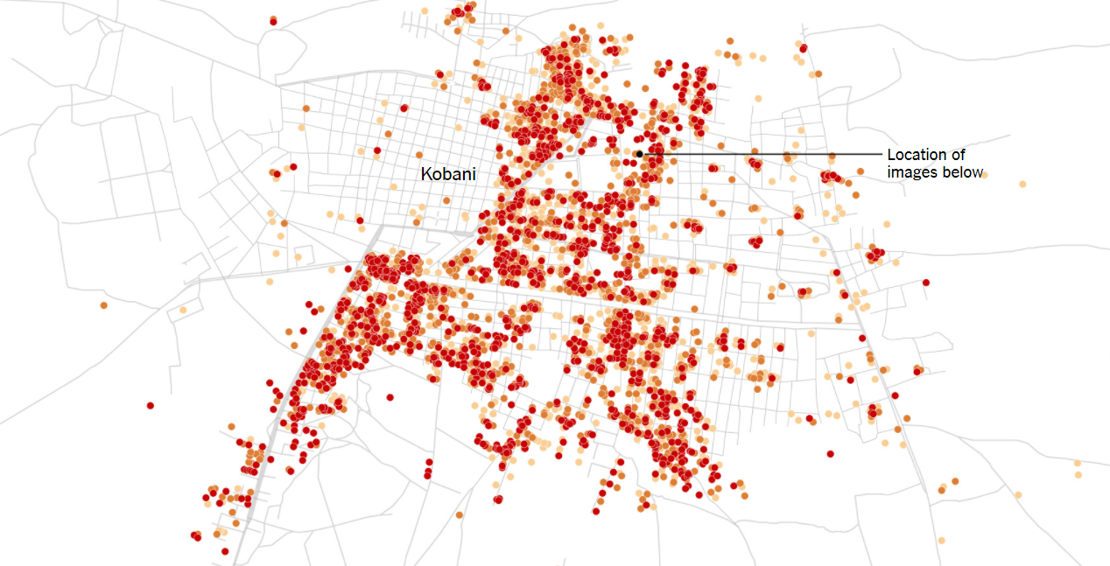
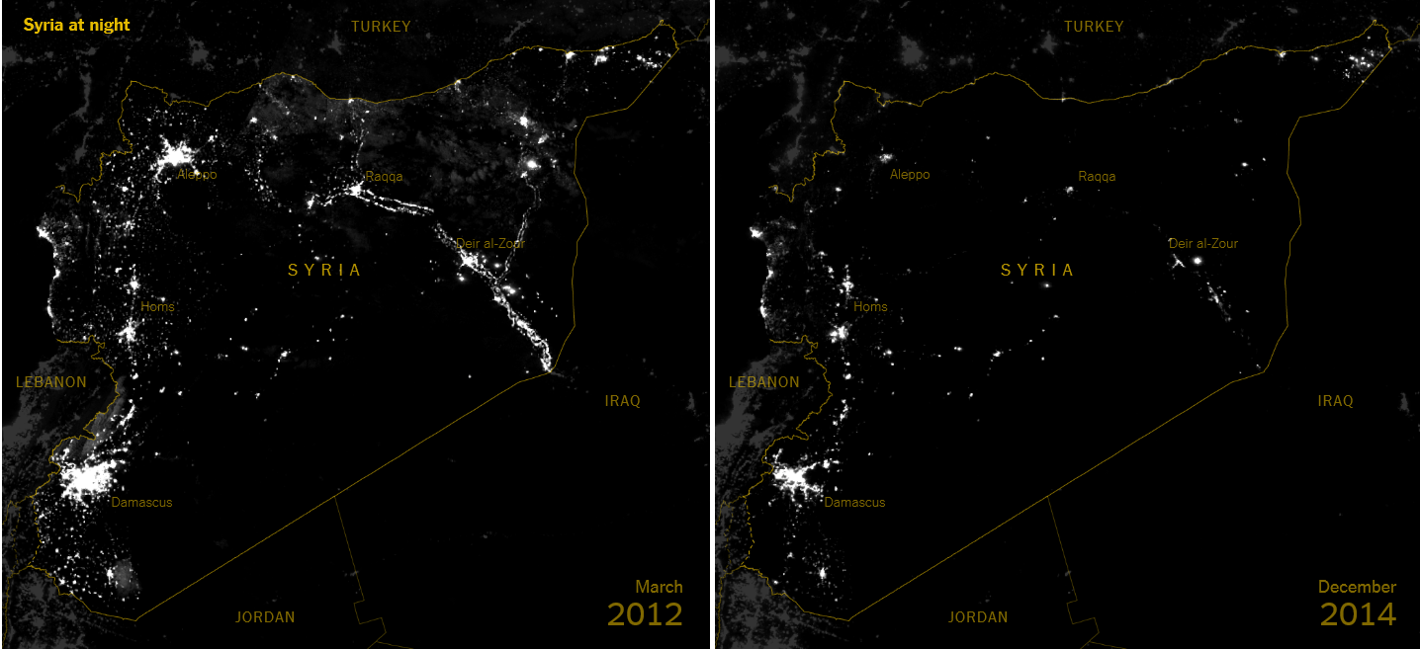
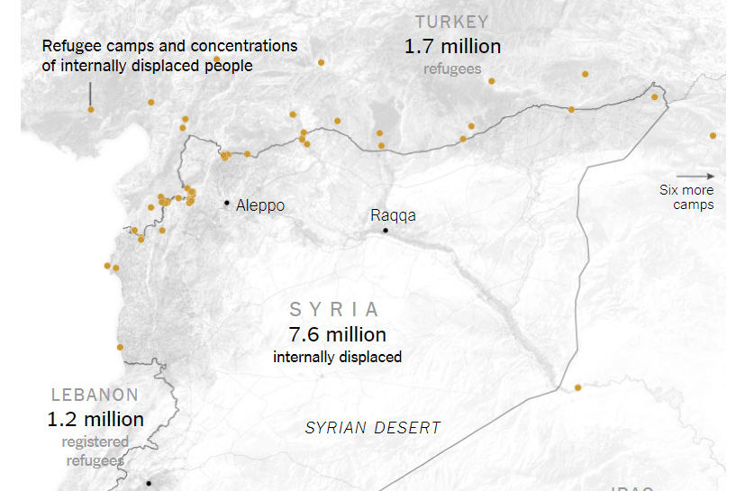
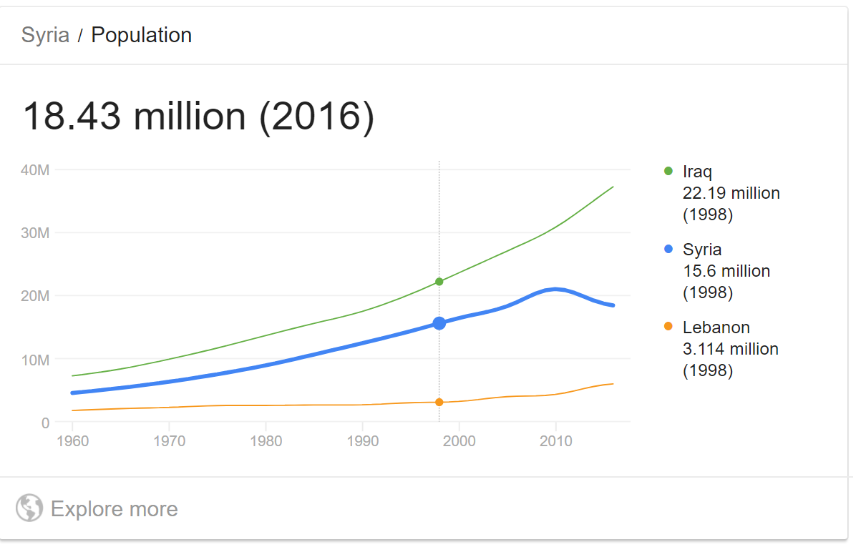

Works Cited
https://www.studentsrebuild.org/blog/2016-12-22/syrian-teenager-describes-her-escape-war-torn-aleppo
https://www.nytimes.com/interactive/2015/02/12/world/middleeast/syria-civil-war-damage-maps.html?action=click&contentCollection=World&region=Footer&module=WhatsNext&version=WhatsNext&contentID=WhatsNext&moduleDetail=undefined&pgtype=Multimedia
https://www.youtube.com/watch?v=aTTzKwLPqFw (Syria in a nutshell video)
http://www.bbc.com/news/world-23813975
https://ourworld.unu.edu/en/loss-of-access-to-education-puts-well-being-of-syrian-girls-at-risk

