http://www.bbc.com/news/world-23813975

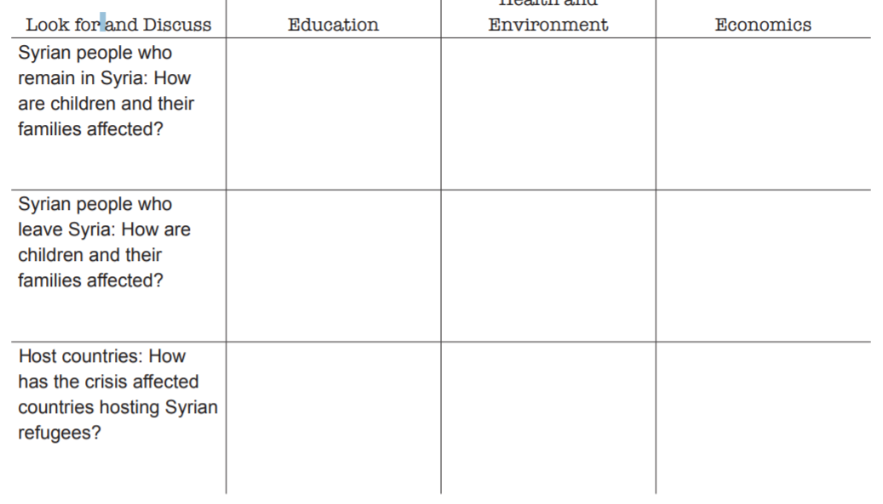
-lack of lights indicates less activity of commerce (ny)
7.6 internally displaced (unu)
-major city allepo major war area for years (ny)
-“struggle to keep power flowing” (ny)

-half of reugees are children displaced including their education (ny)
-people have resentment (bbc) -no arab states take them (kurs)
Syrians getting in to debt for med. , shelter, and transport (bbc)
-=un is not helping much (kurz)
-lebanon - over .7 mill refugees in first 2 yrs with pop of only 4 mill
-job loss because of competitive market (bbc) – Syrians getting in to debt for med. , shelter, and transport

-welcoming at first but now opinion is changing (bbc)
-changing culture “…one in five people are refugees” )bbc)
-Jordanian men cannot provide dowry due to low employment.
-cultural tensions (bbc)
-fears of terrorism are unfounded (kurz)
Lebanon – invited into education but now too much (bbc)
-too many refugees limits education “I feel like I’m in a Syrian school” (bbc) – half school days
-too many refugees limits education “I feel like I’m in a Syrian school” (bbc) – half school days
-=lack of lights indicates less infrastructure and schools (ny)

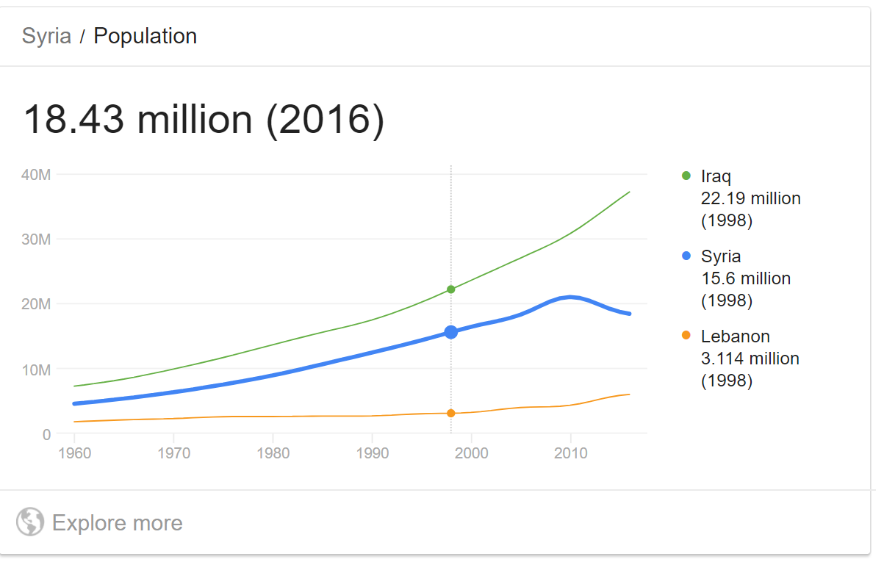

Notes on the youtube video of “Syria in a nutshell”
The European Refugee Crisis and Syria Explained – Notes

- summer 2015 refugee crisis in Europe
  - Syrian crisis
    - Al-Assad (family of dictators) since 1971
  - Arab spring
    - many regimes overthrown (but not Syria)
  - ISIS enters Syria to build totalitarian state
    - war crimes
      - chem. weapons
      - mass executions
      - torture
      - attacks on civilians
    - citizens trapped between…
      - the regime
      - rebel groups
      - religious extremists
  - Syrians flee (refugees) to neighbouring countries
    - called seeking asylum
    - Arab states taking 0% of them
    - UN not prepared
      - spend $ on weapons not aid
    - European states not prepared
    - divides world views on who should help
  - Western fear
    - Islamic/muslim extremism and high birth rates and crime but…
      - extremism? - almost all are peaceful and numbers are small compared to existing population
      - population? – birthrates often change when people immigrate to western countries
      - crime? – most immigrants are not criminals and add to the work force
    - has taken few refugees compared to Jordan alone

https://ourworld.unu.edu/en/loss-of-access-to-education-puts-well-being-of-syrian-girls-at-risk

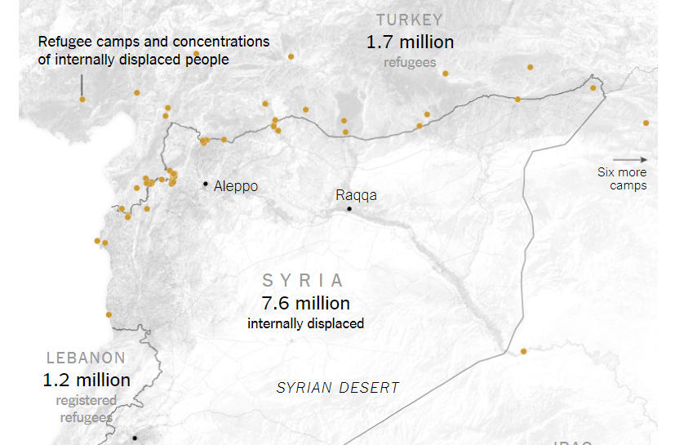
https://www.nytimes.com/interactive/2015/03/12/world/middleeast/syria-civil-war-after-four-years-map.html

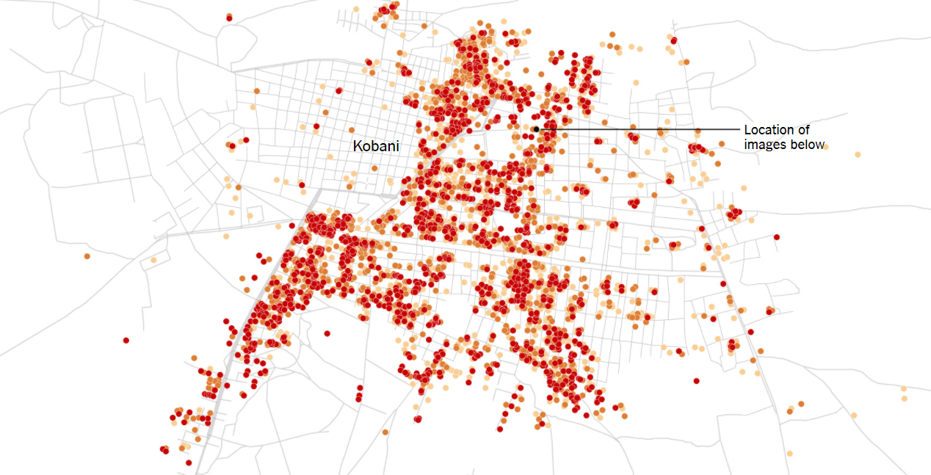
https://www.nytimes.com/interactive/2015/02/12/world/middleeast/syria-civil-war-damage-maps.html?action=click&contentCollection=World&region=Footer&module=WhatsNext&version=WhatsNext&contentID=WhatsNext&moduleDetail=undefined&pgtype=Multimedia
https://www.youtube.com/watch?v=aTTzKwLPqFw

