Arguing For a Theme – The Giver

Today your task is to show your deep critical thinking ability by declaring a theme in The Giver by Lois Lowry. To do this you will start by identifying a topic within the text. Check out the picture of the mind map we created showing many topics in The Giver.
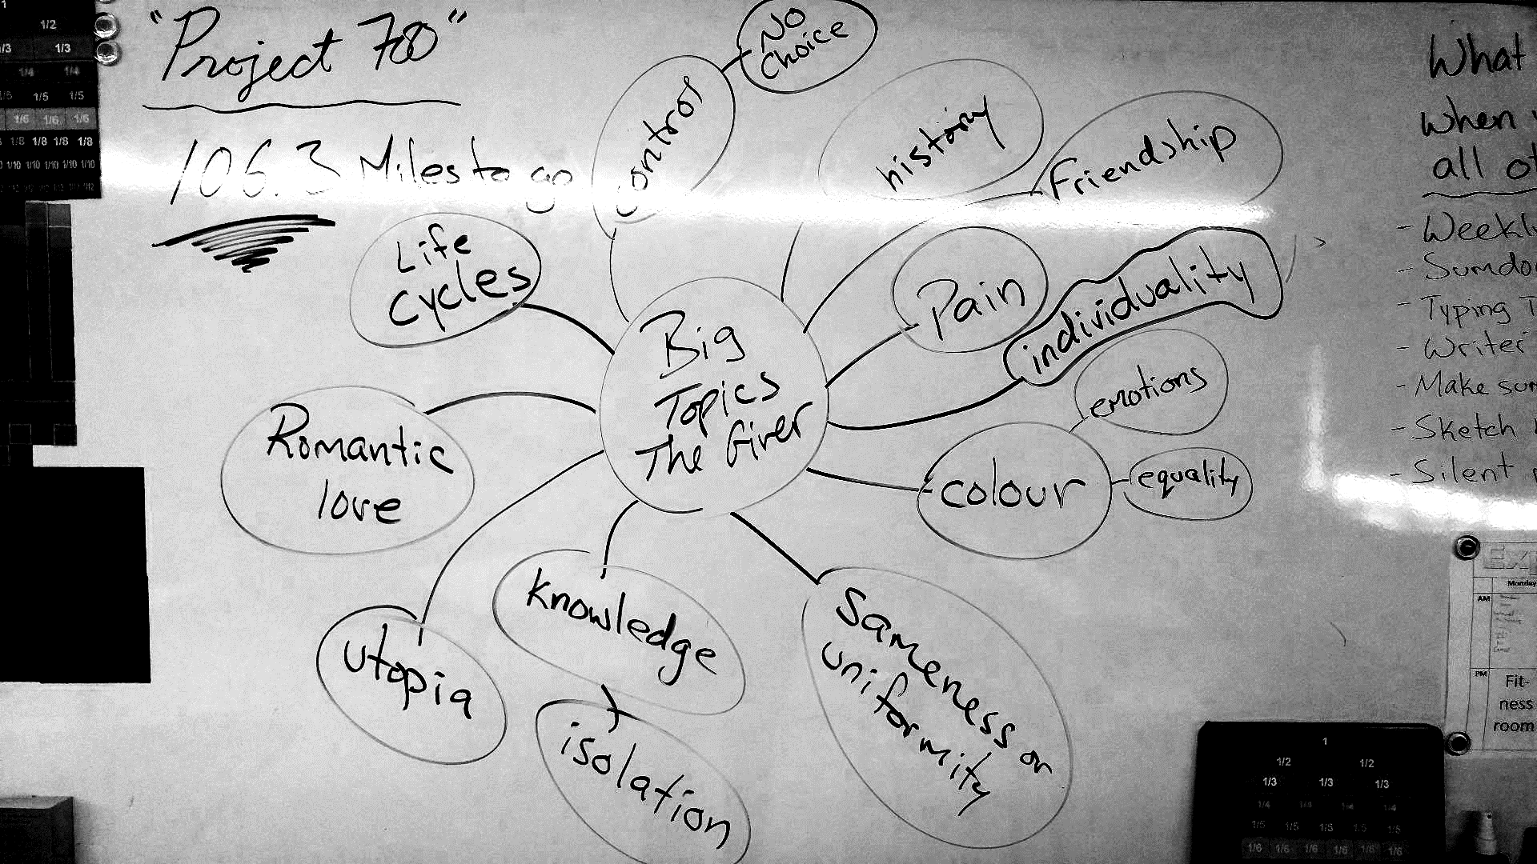
Then you will continue by writing a declaration sentence such as “I think that Lois Lowry believes _________________ about __________________. Remember this one from class? That was the ‘snowball’ activity that we did. You will later take this sentence to turn it into a theme statement.
Once you have made your theme sentence and you will find at least 3 examples of when that topic shows up in the book. You will write those examples in the chart below. This will help you to organize your thinking for your final written assignment. Check out the example below taken from The Hunger Games by Suzanne Collins (below). These examples are shared directly in the “Character and Defining Moment” section of the chart.
Once you have found all 3 (or more) examples you must then explain how those examples of the theme appearing in the book are helping to advance the theme. In the example below it states it is one of the first moments of human spirit toppling the government.
EXAMPLE:
Declaration sentence: I think Suzanne Collins thinks that an oppressive government cannot defeat the fighting spirit of the common class so long as they refuse to keep fighting.
In this example the topic was “oppression”
Theme: Oppression is no match for the fighting human spirit
Character and Defining Moment | Analysis of how this advances the theme
Katniss Everdeen: Right after Katniss offers to take her sister’s (Prim) place in the Hunger Games her mother is asking her to try her best to survive. She replies, “…it isn’t in my nature to go down without a fight, even when things seem insurmountable…and I know, because of Prim, I’ll have to.” (page 36) | This shows how Katniss is resolving to never quit in order for her to be able to come back to her family. This is a clear defining moment of a common person expressing personal motivation to fight for not only their survival but their families. Her human spirit is motivated by her love for her family and she will never quit no matter how oppressive her government becomes; even in bloodsport. This moment is only the beginning of the fighting spirit that Katniss will create in her society.

Now that you have completed all your research and organized your ideas into an organized chart you need to bring it to Mr. Ewert for discussion. He will likely give you some advice or insight into your project prior to the final writing portion.
You are now ready to write you argument. To do this you will write:
- An introductory paragraph stating a theme of The Giver.
- A paragraph for each defining moment you have found that shares your theme within the book and how it advances the theme in the story.
- A concluding paragraph that reminds the audience of what your theme is and how it advances throughout the book. A short summary.
Last step: fill out the rubric and hand that bad boy in.

Here is a checklist to help you make sure you did everything you were supposed to do (actually check them off to make sure)
Did you…
- Choose a topic from the book
- Make a declaration sentence that states what the author believes about that topic
- Turn your declaration sentence into a statement of a theme
- Find at least 3 examples of that theme occurring in the book
- Fill out the chart with each of those examples
- Explain each of those examples in the “analysis of how this advances the theme” section
- Discuss your progress with Mr. Ewert for any last minute suggestions
- Write an introductory paragraph stating your theme
- Write a separate paragraph for each of your defining moments including direct evidence from the book
- Write a concluding paragraph reminding the audience of your argument (summary)
- Fill out the rubric below
- Attach all your materials together in exactly this order
  - The assignment (this paper)
  - The “Arguing For a Theme” chart
  - The final copy of the written work that argues your theme
Arguing For a Theme
 | 1 | 2 | 3 | 4
Writing | The assignment is in need of greater organization. Topic may be unclear with few supporting points. More factual evidence may be necessary with more detailed explanations to share the writer’s thoughts. Paragraph formatting and mechanical editing may be an issue. |  |  | The assignment is well organized with a clear topic, supporting points, factual evidence, and logical conclusions. All mechanical editing is present with impeccable paragraph formatting.
Research and Communication | The students has shared only some of their ideas with a need for more research. Evidence of deep critical thinking is lacking and more detail and/or organization is necessary. Direct examples may not be present or are inaccurately explained. |  |  | The student has clearly shared their project with a focused presentation that accurately shares their ideas, research, and deeper thinking about their reading. They have included direct examples of when their theme occurs within the text and clearly explained how it advances throughout the text.
Critical Thinking | The project reflects little personal opinion or understanding of the narratives deeper ideas and purpose. Either more work or personal insight is required in order to share the student’s thinking about what they have read. |  |  | The student has shared clear evidence of deep understanding of the narrative. Their project directly reflects personal opinions about the themes, purpose, and style of writing.
Total |  |  |  | /12
Additional Notes:

Arguing For a Theme – Organization Chart
Theme:

Character and Defining Moment | Analysis of how this advances the theme
Theme:

Character and Defining Moment | Analysis of how this advances the theme
Theme:

Character and Defining Moment | Analysis of how this advances the theme
Theme:

Character and Defining Moment | Analysis of how this advances the theme
Theme:

Character and Defining Moment | Analysis of how this advances the theme
Theme:

Character and Defining Moment | Analysis of how this advances the theme

