Lab Rubric
4 3 2 1
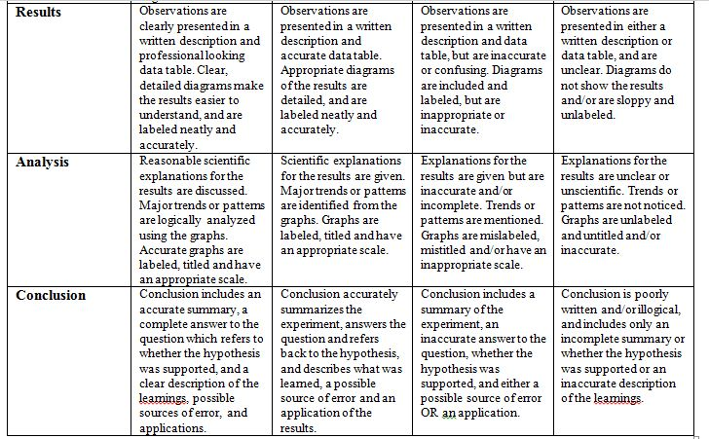

Lab Rubric
4 3 2 1

