The Little Prince – Final Essay Project
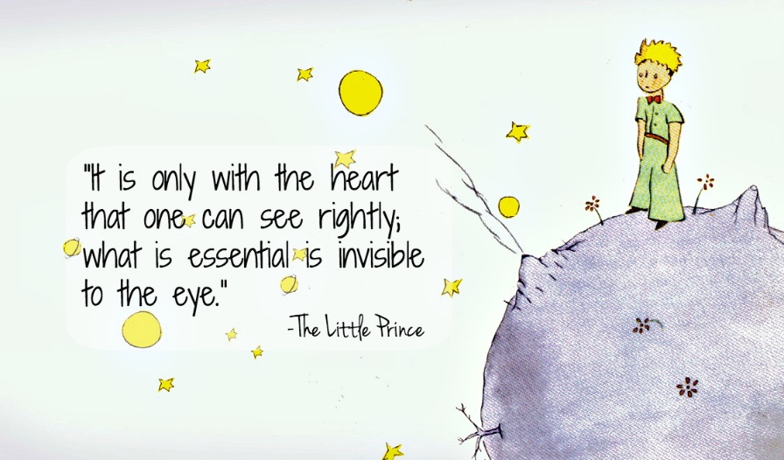
*For this project you will first need to learn how to write a proper essay. To do that you will want to access some of the resources on Mr. Ewert’s blog outlining different organizers and methods for planning and writing an essay.
Steps to completing this assignment:
- Learn how to write an essay
  - Be attentive to the in-class instruction so you know exactly what to do.
  - Go to Mr. Ewert’s blog to access materials that you will need.
  - Ask questions if you are uncertain.
- Consider what you are trying to say
  - What do you think the big idea about The Little Prince is? (What do you think the author is/was trying to say. What is it really about?)
    - You will need to be CLEAR about this prior to moving forward.
- Plan out your essay
  - Choose a template to write your essay with. Mr. Ewert will review all of these in class. Be sure that you choose a template that fits your way of thinking and the message that you are trying to share about the book.
  - Fill that template in with all of your deep ideas.
- Write your essay
  - Using your template write out your ideas in proper paragraph format. Be sure to use strong topic sentences that are backed up with supporting points and direct evidence.
    - Review your essay assignments from class for how to do this.
  - Consider the order of your sentences. Are there any rearrangements to be made? If so, make the change. If not, publish that bad boy.
  - Review the rubric and ensure that you have made a powerful essay that follows the guidelines.

 | 1 | 2 | 3 | 4
Structure/  Organization | The overall structure and/or individual paragraphs are disorganized. | The structure is incomplete. The paragraphs are lacking elements. There is much room for improvement. | There is an intro, body, and conc. Paragraphs contain most necessary elements but there room for improvement. | There is a solid introduction, body and conclusion. Each paragraph is complete with statement, explanation, evidence, and conclusion.
Argument/  Comparison | The argument is missing. The writer does not express an opinion. | The argument is unclear making the focus of the work confusing. | The argument is stated and developed, however, there is room for improvement. | The thesis is clearly stated and develops logically throughout the work.
Evidence/  Proofs | There is no factual evidence. The thesis is not proven. | There is little use of evidence to argue to opinion of the writer. | Evidence is used to argue the thesis but there is room for improvement. MLA format needs work. | Proper evidence is used to support the thesis. Proper MLA format is used.
Mechanics/  Editing | The work is full of mechanical errors making it confusing to the reader. | There are many mechanical errors and much editing is needed. | The mechanics are well done but there are some errors. | The mechanics are impeccable.

