Ray Bradbury Theater: Discussion Questions
You will watch several episodes of Ray Bradbury Theater, based on the short stories of Ray Bradbury. Then you will select four stories and answer the discussion questions in writing. For each question, write a fully developed paragraph including details from the text (the film) to support your statements.
Select four stories and answer the discussion questions for them. These are your choices:
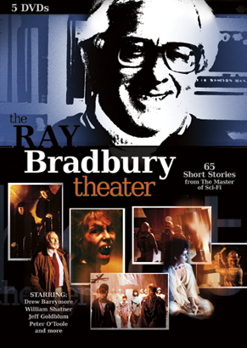
- Mars is Heaven
- The Playground
- Skeleton
- The Veldt
- The Screaming Woman
- Tyrannosaurus Rex
- Zero Hour
Include the title on each sheet of paper:
Discussion Questions for “Title of Short Story” by Ray Bradbury

Discussion Questions for “Mars is Heaven” by Ray Bradbury
- Notice what happens when the astronauts are touched by their loved ones. What do you think happens when they are touched? Also notice how the astronauts are encouraged to drink. What is happening here?
- Describe the inner conflict Captain Black is facing. Why is he confused? What forces are conflicting inside his mind?
- Captain Black finally comes up with a theory of what is happening. What does he think is happening? Is he right? Give evidence to prove your answer.

Discussion Questions for “The Playground” by Ray Bradbury
- What are some of the messages Ray Bradbury sends to his readers about the nature of children? Use details from the story to support your statements.
- What is Ray Bradbury saying to his readers about confronting or hiding from our fears? Use details from the story to support your statements.
- Describe what happens at the end of the story. How does this ending support Bradbury’s message about the nature of children or the effects of confronting or hiding from our fears?

Discussion Questions for “Skeleton” by Ray Bradbury
- Ray Bradbury uses humor in this story. What makes you laugh and how does Bradbury craft the story to make it funny?
- What is Bradbury saying about hypochondriacs, or those who are always seeking out doctors with the belief they are ill and can be cured?
- What is Bradbury saying about those who offer cures that are outside the realm of accepted medical practice? Can you describe a practice that people use as a cure which is most likely not helpful, or perhaps something people did in the past?

Discussion Questions for “The Veldt”
- According to Ray Bradbury, how did the parents fail in their job of raising their children?
- What is the message Bradbury is sending to his readers about technology and what it is doing to families and relationships? Use details to support your statements.
- Explain why the children do what they do at the end of the story. What is their perspective?

Discussion Questions for “The Screaming Woman”
- What is Bradbury showing to the reader about people’s assumptions about the value of reading science fiction? What do you think is his view of this?
- Describe what Bradbury is saying about how much people believe in what children say. What do you think is his view of this?
- Describe the author’s craft in this story. How does he make it scary?

Discussion Questions for “Tyrannosaurus Rex” by Ray Bradbury
- What is the message Bradbury is sending to his readers about both artists and those who finance, or pay for, their work.
- Describe why it is ironic when Joe Clarence screams to the Claymation artist, “Don’t you know what a monster is?”
- How does the lawyer use Clarence’s ego to save the artist’s job? How does this add to the author’s message about people who control art?

Discussion Questions for “Zero Hour” by Ray Bradbury
- Describe what Bradbury is saying about how much people believe in what children say. What do you think is his view of this?
- What do you think is controlling the children? Use evidence from the story to support your statements.
- What does this story say about our fears about outer space and creatures from another planet?

