**Zombie Geography – Choose your region**

The time has come to choose where you will begin your journey through the zombie apocalypse. But to do this you will first need to consider where in the United States is a smart place to begin. To do this you will need to analyze various maps in order to decide the best possible place to be. You will need to consider…

* Where the zombies will go…
  + High or low land?
  + Open areas or closed?
  + Near resources or away?
  + Rural or urban areas?
  + And much much more.
* Your personal survival
  + Where are supplies?
  + Where are allies?
  + Where is it easy to get to?
  + What place has what you will need in the long run?
  + Etc., etc., etc.

Use the tables below to justify your thinking in choosing the region to begin.

|  |  |
| --- | --- |
| Type of Map: | |
| Type of info (and why it is important in the apocalypse): | |
| Advantages Found | Disadvantages Found |
|  |  |
| **Don’t Forget to print a copy of the map to indicate the advantages and disadvantages you identified.** | |
| Conclusions (according to this map only where might be a good place to go for the zombie apocalypse?): | |

|  |  |
| --- | --- |
| Type of Map: | |
| Type of info (and why it is important in the apocalypse): | |
| Advantages Found | Disadvantages Found |
|  |  |
| **Don’t Forget to print a copy of the map to indicate the advantages and disadvantages you identified.** | |
| Conclusions (according to this map only where might be a good place to go for the zombie apocalypse?): | |

|  |  |
| --- | --- |
| Type of Map: | |
| Type of info (and why it is important in the apocalypse): | |
| Advantages Found | Disadvantages Found |
|  |  |
| **Don’t Forget to print a copy of the map to indicate the advantages and disadvantages you identified.** | |
| Conclusions (according to this map only where might be a good place to go for the zombie apocalypse?): | |

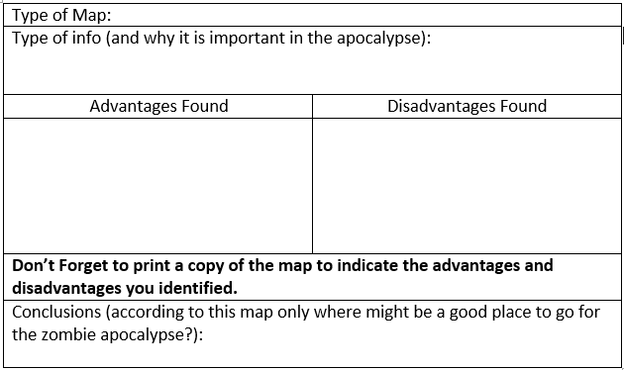

Final observations (explain in detail where you plan to be and how analyzing different maps helped you decide) _________________________________________________________________________________________________________________________________________________________________________________________________________________________________________________________________________________________________________________________________________________________________________________________________________________________________________________________________________________________________________________________________________________________________________________________________________________________________________________________________________________________________________________________________________________________________________________________________________________________________________________________________________________________________________________________________________________________________________________________________________________________________________________________________________________________________________________________________________________________________________________________________________________________________________________________________________________________________________________________________________________________________________________________________________________________________________________________________________________________________________________________________________________________________________________________________________________________________________________________________________________