Fourquations – The Dice Game for Math Legends

Purpose - The purpose of this game is to make equations that have four numbers and have a low final answer. This gets you points in the game. The first player to 10 points wins.
- This is done by rolling dice and then creating an equation using four of the numbers.
- For example:
  - If this was the roll then you could make equations using four of the different numbers. Perhaps I could use the numbers 2, 10, 5, and 2. Then I could make the equation 2 X 10 ÷ 5 – 2 = 3 (by the way, forget about order of operations for this game)
Number of players – 2 to 5
What you Need to Play –
- 2 to 5 people
- I set of game dice (6 sided, 8 sided, 10 sided, 12 sided, and 20 sided)
- 1 30-second timer
- Paper and pencil for each player to write down their equations to share. (you can also use whiteboard “show me” boards)
Objective – Be the first player to get 10 points to win. You get points by winning rounds of the game.
How to Play – Set the timer for 30 seconds and start it. One player rolls the dice for the group. During the 30 seconds the players all look at the dice and try to make an equation that uses 4 of the numbers. Once the timer counts down to zero the players take a moment to record their equations on paper (or “show me” boards). Starting with the player that rolled they each share their equations in order from the rolling player and then going clockwise around the circle. Once all players have shared their equations the one that works with the lowest answer is the winner of the round and gets a point.
In the event that two players each have a 4 number equation that equals the same number, then the player that used the greatest sum of numbers wins.
- For example:
  - 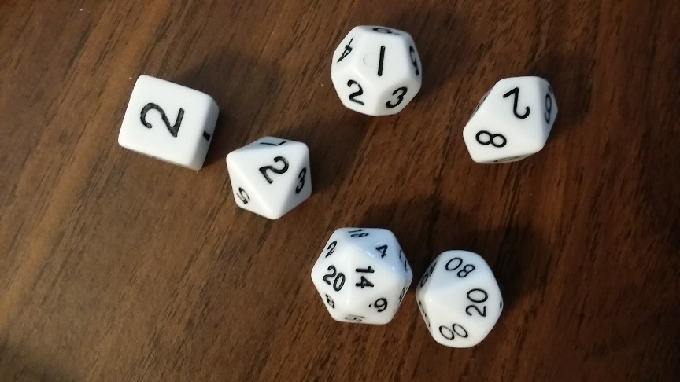
  - Example #1
    - Player 1 -> made the equation 1 X 20 – 14 ÷ 2 = 3
    - Player 2 -> made the equation 2 X 14 – 20 ÷ 2 = 4
      - In this example Player 1 made an equation with 4 dice that has an answer of 3 which is lower than the answer to Player 2’s equation. So, Player 1 will get a point for this round.
    - Player 1 –> made the equation 1 X 20 – 14 ÷ 2 = 3
    - Player 2 –> made the equation 2 X 2 - 2 + 1 = 3
      - In this example both players made equations out of 4 of the dice that ended with an answer of 3. Since the answer are both equally low numbers there is no clear winner. In this example the player that has the highest sum of all the numbers they used will be the winner.
        - sums:
          - Player 1 –> 1 + 20 + 14 + 2 = 37
          - Player 2 – > 2 + 2 + 2 + 1 = 7
            - Since the sum of Player 1’s dice is more he will win 1 point for this round.
How to Win: Be the first player to win 10 rounds for a total of 10 points.

