**Photography Project**

By, Montana Bochurka

***Simplicity***

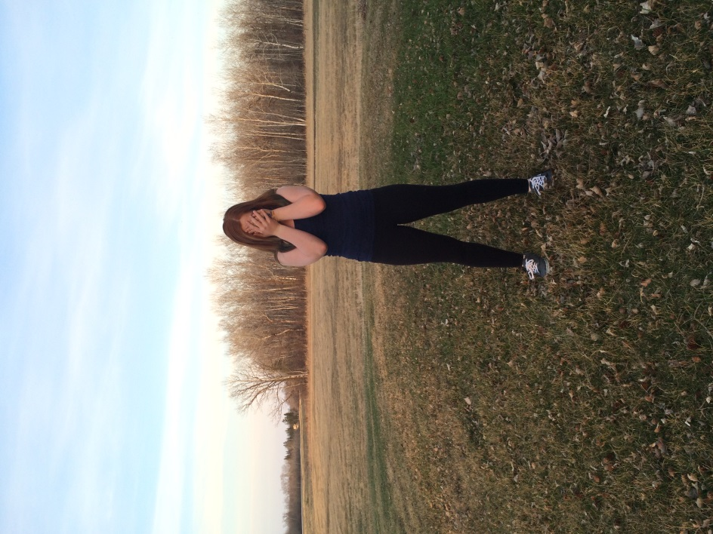

This photo is simple because, there are no distractions in the background, I am slightly off center and I stand out in this because I’m wearing a dark shade so I’m standing out in it, but not too much.

***Lines***

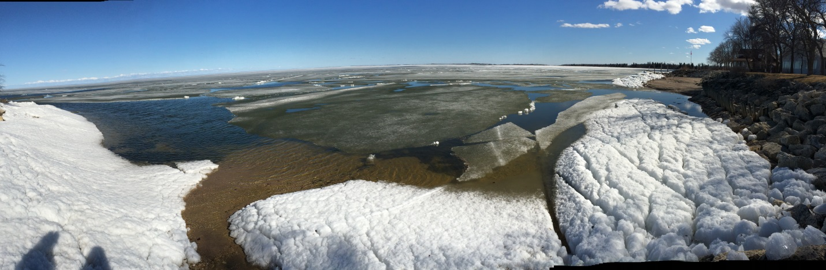

This photo fits with lines well because there is a line separating it from the ice/surface, there are different shapes in the ice so it makes it look more interesting and it’s not “basic” it’s interesting its different and it spreads out very well.

***Balance***

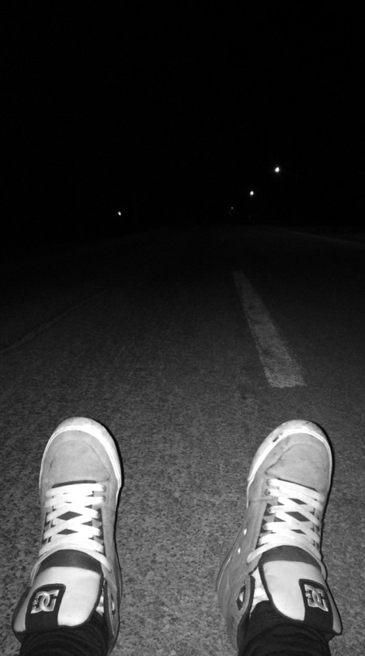

This fits in with balance very well because, its light by my feet and out into the distance its darker, the lights in the distanced area make it look even more balanced because it’s not too dark not to bright and it doesn’t divide into separated things it’s pretty much equal.

***Avoid Mergers***

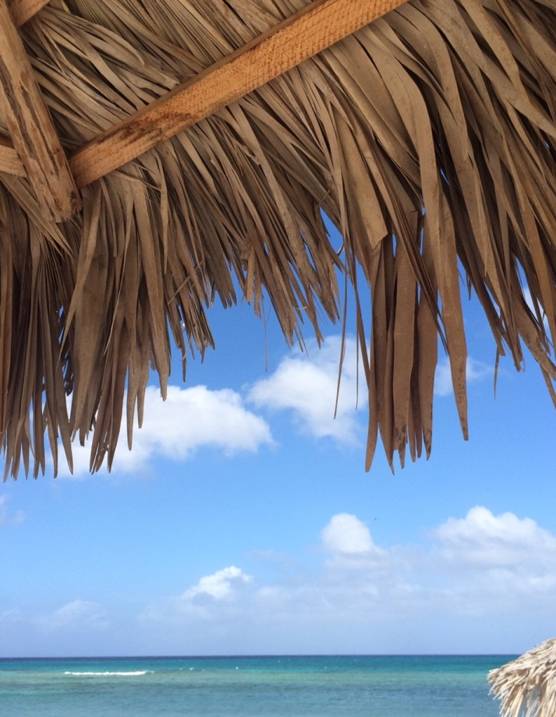

This fits in with Avoid Mergers because, the “cover-up tree” does not cover the ocean view, I’m not cutting off any parts of anything, it all blends very well together and it’s a simple background.

***Cropping***

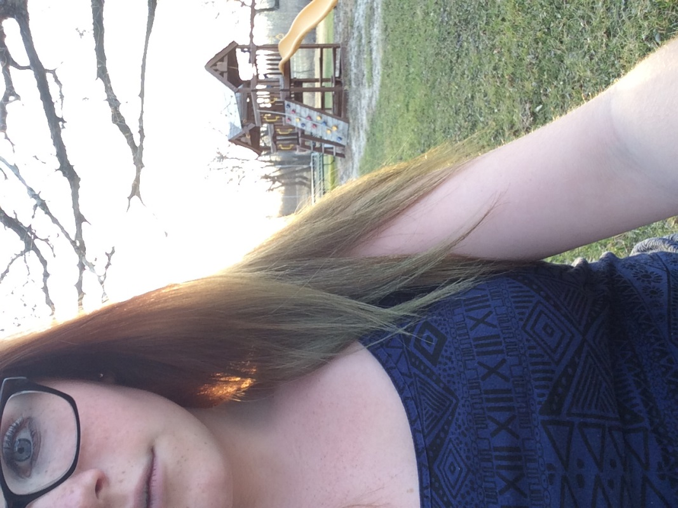

This photo fits in with cropping well because it’s focused on the main part of the picture I wanted to show and it has part of my hair in it so it looks like there’s more detail.

***Framing***

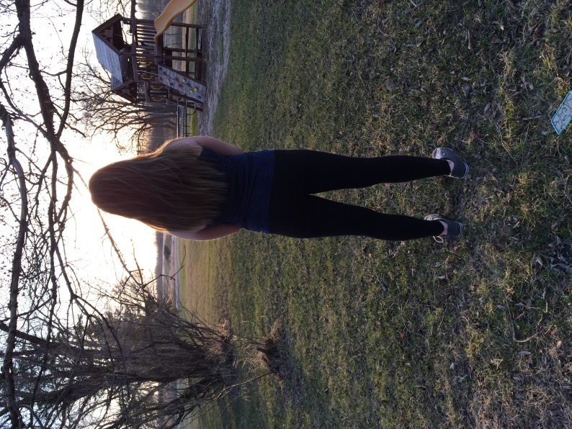

This photo fits with framing because, the treehouse and the trees are framing me, and there is nothing in front of me so it looks like framing.

***Rule of Thirds***

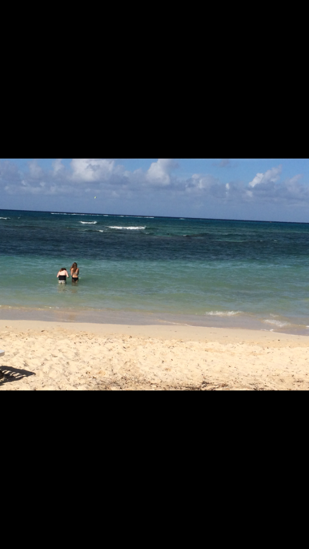

This follows the rule of thirds because, Meadow and I are not in the middle of the picture, we are on the side so it look more professional and it’s a pretty simple background.

I don’t really have a favourite, I like all of them pretty much the same.