5 Rules of composition
By Eric

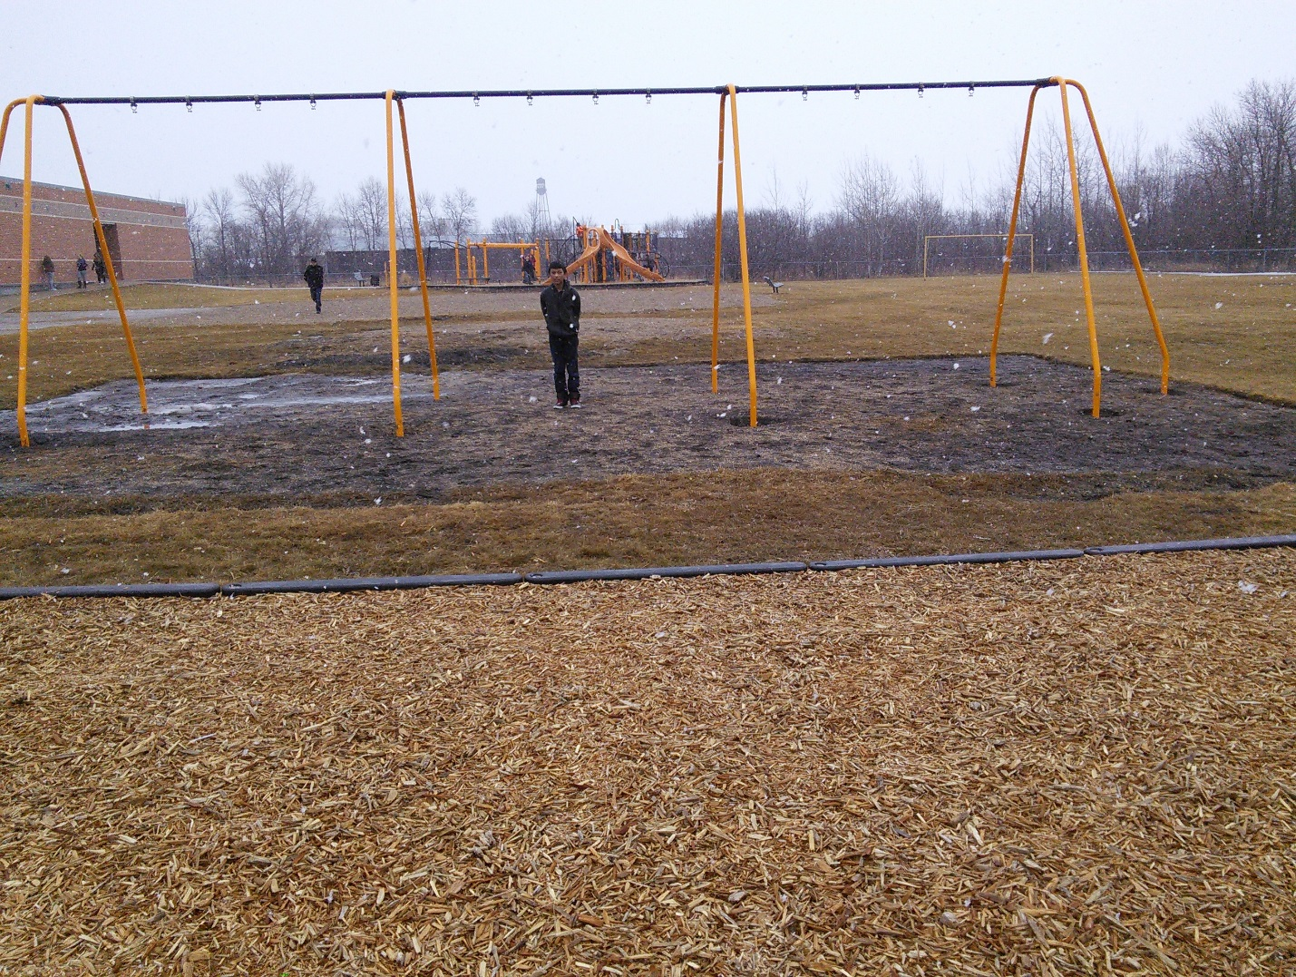
Naturel framing
The first rule I will talk about is framing. When you are taking pictures you want to remember the rules of composition. One is Naturel framing. With this rule you want to use naturel objects to frame the main part of your image.
The picture above is representing the rule of framing. Notice how within the image the bars on the half built swing set are framing the person in between them. Now the subject becomes more visible and stands out of the photo for people to see.
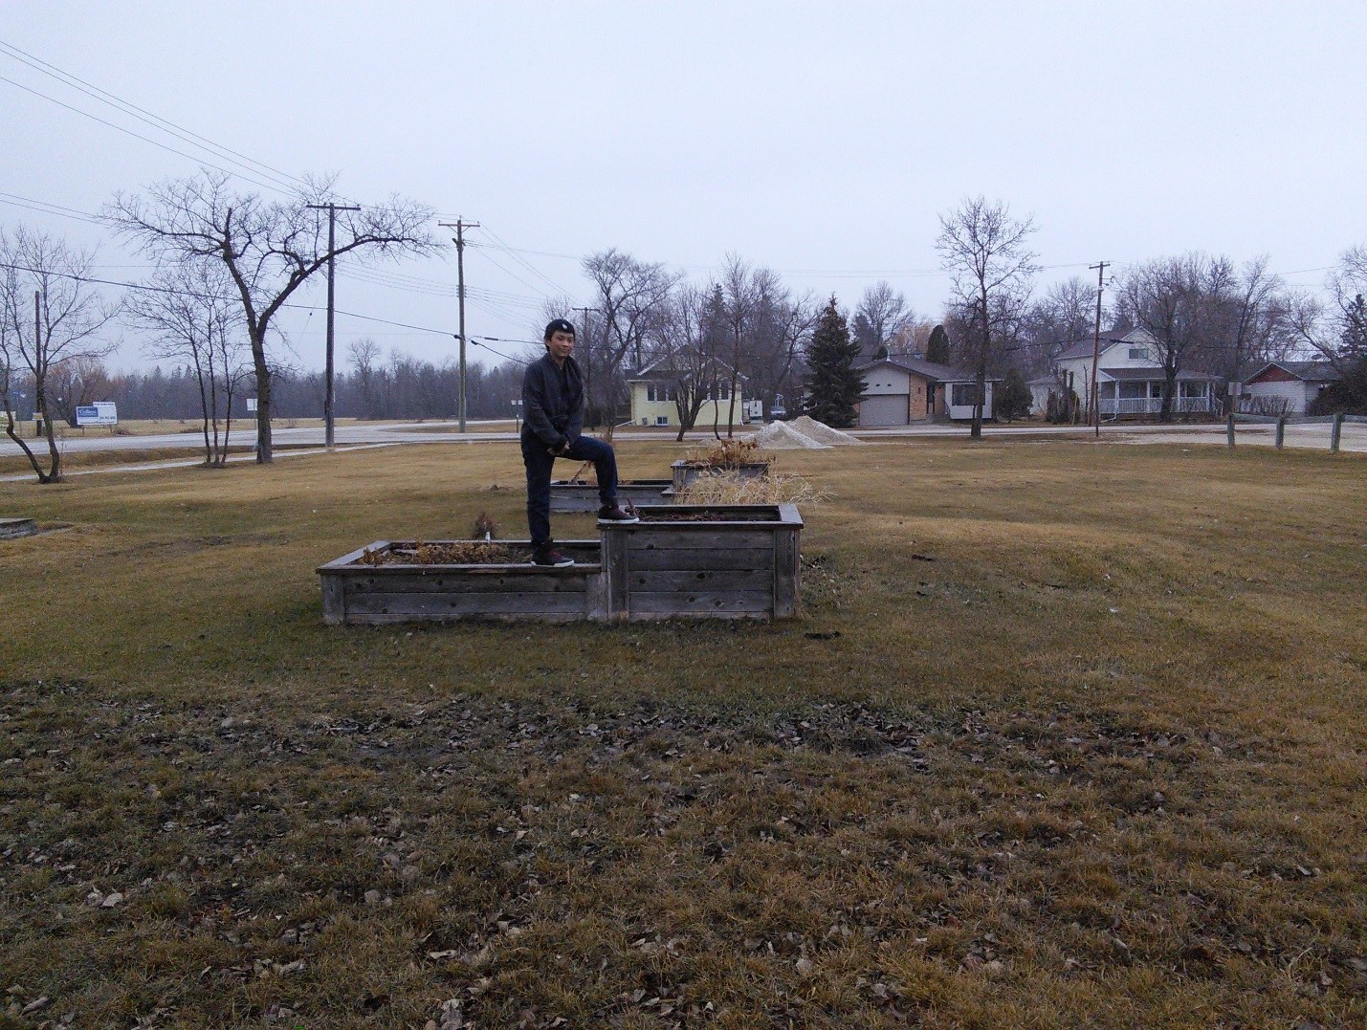
Lines
The next rule in good photography is called lines. In this rule try and find naturel lines that will lead the people’s eyes right to the subject of the photo. That makes the person looking at it focus on the main subject of the photograph instead of things in the background. In this photo the wooden planters are the naturel lines in this photo. The lines lead to the person on top of the planters witch is the subject of the photo.
Balance The next rule is balance. When taking a photo you want to balance out your photo. In this photo the frozen lake and the cloudy sky are balancing it out the photo. You don’t want too many things on one side and not as much on the other.
Simple background In this photo the simple background rule is being represented. The lake is the simple background in this photo. If you have to much in the background then people will not focus on the main subject in the photo.
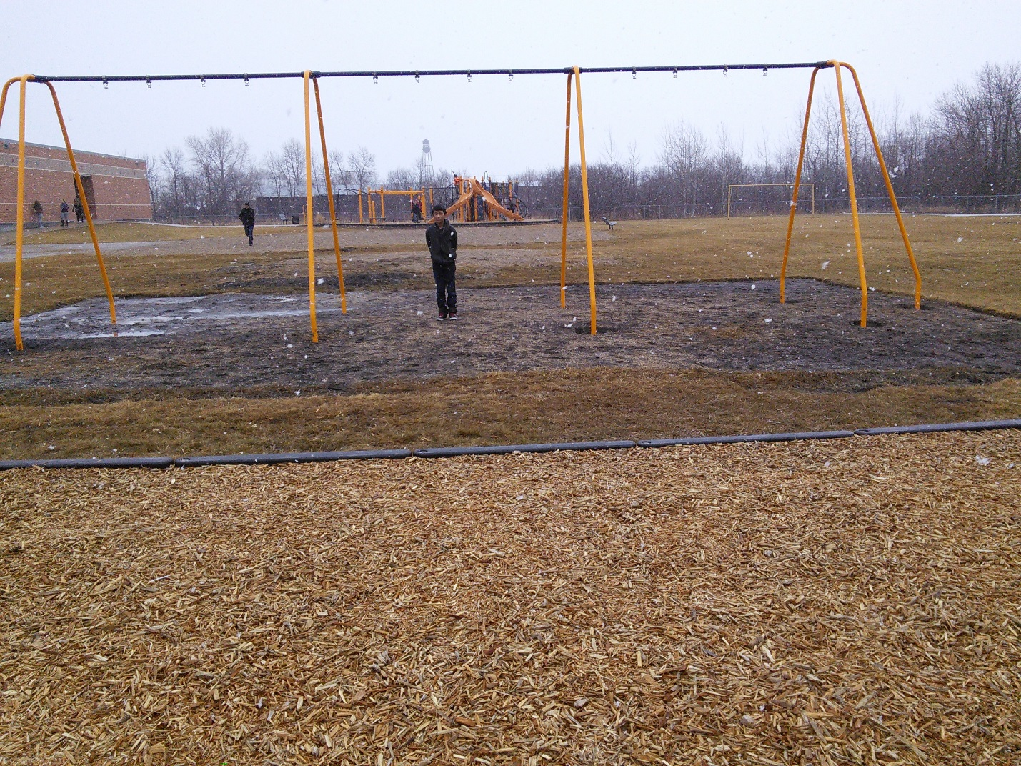Rule of Thirds This represents the rule of thirds because the subject of the photo is off to the side just a bit. If the photo is right then people won’t look at anything else in the photo.

