The Art of Composing Pictures: 7 Rules of Composition

SIMPLICITY
- Choose simple, uncomplicated backgrounds.
- Avoid competing with unrelated subjects in your composition.
- Move in close.
- Place subject slightly off center.

LINES
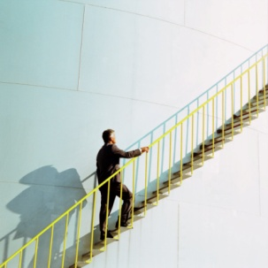
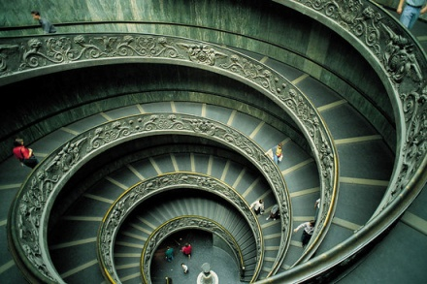

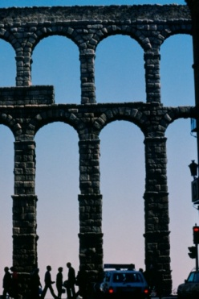
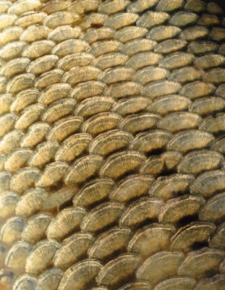
- Keep your photograph simple.
- Use lines to lead viewer into picture’s center of interest.
- Use “S” curve to add interest.
- Use Geometric shapes to add interest.

BALANCE
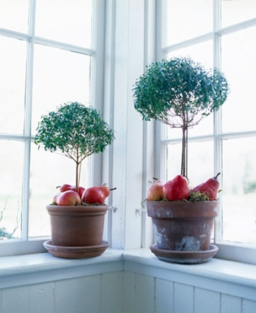

- Balance composition symmetrically or asymmetrically
- Use balance that unifies, not divides.
- Use arrangement of shapes, color, areas of light and dark in a complementary way.

AVOID MERGERS
- Remember to look at your background.
- Choose simple backgrounds.
- Change point of view by moving left or right, up or down.
- Don’t cut off people’s heads or feet.

CROPPING

- Use cropping to correct or improve your photograph.
- Include portions of photograph that are most important.
- Crop horizontally or vertically.

FRAMING
- Use foreground (i.e. trees or foliage) to frame subject.

RULE OF THIRDS
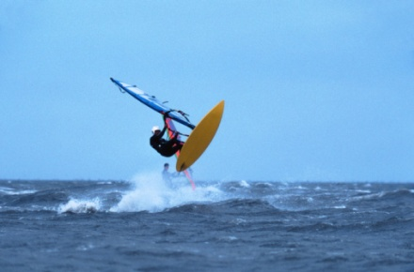

- Avoid placing subject in the middle of the photograph.
- Place horizon line at top or lower third of photograph.
- Leave space in front of moving subjects.
- Place subject on one of the four key positions.

Assignment: Students will go on a walk through the school and in the surrounding community to find pictures they can use to represent the rules of photography. They will consider the rules of composition when taking the photos. They will need many photos to choose from so shoot liberally. Once they have all the pictures they need they will return to class to upload the photos to their computers Students will choose 5 of the 7 basic rules of composition to represent with their photos then critically consider the photos and choose one photo to represent each of the composition rules they have chosen.

For each of the rules the student must:
- Share one picture they feel strongly represents that rule of composition.
- Create a write-up between 50-150 words explaining what that rule of composition is and how that photo represents or follows that rule.
The end product: Students will have 6 pages
- One cover page with a title relating to the rules of composition
- One page for each rule they chose to represent that includes the photo they have taken/chosen complete with the explanation of how that photo follows the rule they have chosen to represent.
- Total pages = 6

https://www.youtube.com/watch?v=7YhosnrH7Gs

https://www.youtube.com/watch?v=7XSsV0ZddeU
https://www.youtube.com/watch?v=7ZVyNjKSr0M

