From Sea to Sea Notes on Chapter 3

- Read first section on page 32 together
- RCMP (Royal Canadian Mounted Police
  - forming in NWT
  - many young men after Western adventure
- From Sea to Sea
  - dream of John A McDonald and the “Founders of Confederation”
    - many problems face them
      - 1st – First Nations land needed for settlement
      - 2nd – Illegal Whiskey trade
      - 3rd – drive out American hunters and traders
- May in 1873 – Cypress hills, SK
  - 36 Nakota killed by American whiskey traders (want to hunt there)
    - MUST bring law and order to the west
      - creates the NWMP
- NWMP formed
  - 300 men trained in Fort Garry
  - 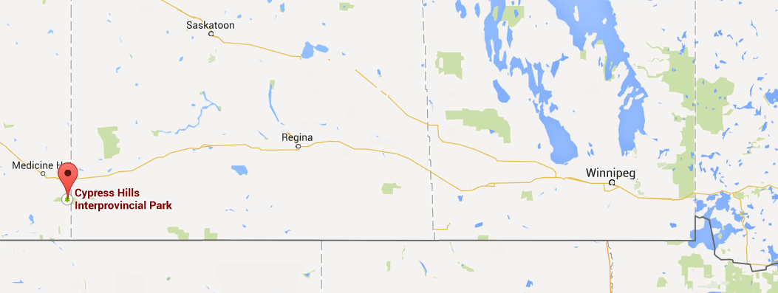
    - Head out to Cypress Hills (1500 km away)
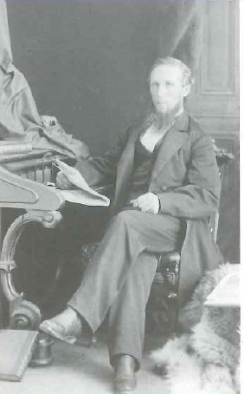
- Meanwhile – new gov’t
  - McDonald our and McKenzie in
    - Mckenzie
      - believed in equality
      - editor of a newspaper “The Reform”
        - Dominion Elections Act – 1873
          - secret ballot elections
- The Great March West (p.34)
  - 300 men going 1500 km
    - half go to Fort Whoop-Up and Half North
    - 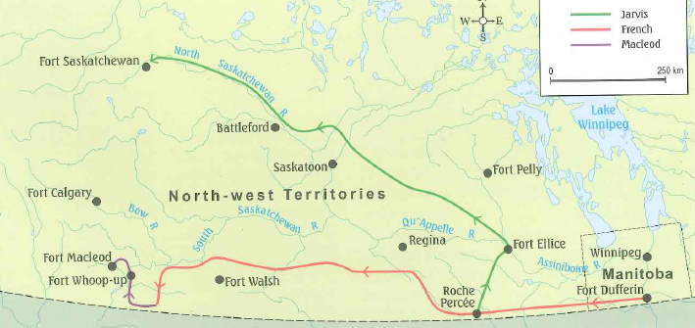
    - problems
      - mosquitos, bad water, severe weather, dead horses
- NWMP built forts across MB and SK
  - needed good relations with First Nations (FN)
    - provided:
      - medicine, food, mail, justice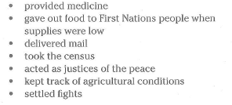
- BC Joins Canada (and the gold rush)
  - many people flock there (1849 – 1857)
    - make $5-12 dollars a day (like $700+)
    - California Gold Rush moving here
  - 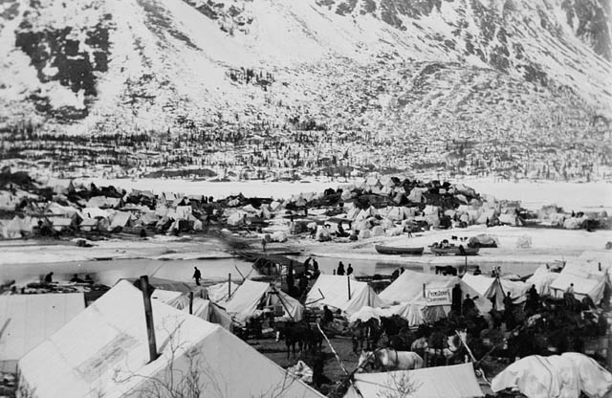
  - Frasier river gold rush camp
    - end of 1857 over 30,000 camped out
      - worry of invasion on FN and Can. land
- Railway!
  - spreading westward
    - Pacific Scandal
      - John McD. accepting $ for 1872 election
    - 1878 - John McD returns to office
    - 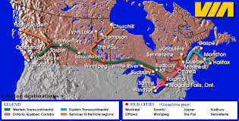
      - liberal party (Lib.) had expanded from 1873-1878 – Conservatives (Cons.) want it finished
        - Commission CPR to connect to existing line from the coast
        - rough terrain
          - took over 9,000workers (mostly Chinese)
            - dangerous (over 700 died)
        - fin. 1885
- More prov. and territories
  - P.E.I.
    - never joined in 1867 (smaller needs and anti-taxes)
    - joined for…
      - relief from rail taxes
      - guarantees of trade
      - representation in parliament
  - Yukon
    - given independence as a territory

