Treaty Education – Essential Teachings – Assignment
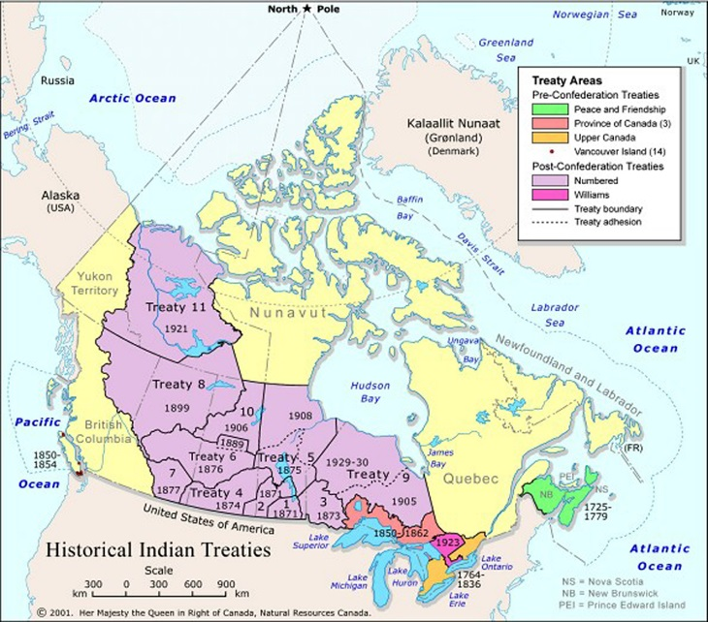
*In this assignment you will be responding to questions on treaty education. Answer the questions below. Don’t forget to observe the rubric for how your answers will be assessed. Please answer these questions on a separate piece of paper. Remember: these are critical thinking questions (they require personal thought and details to make it clear that you understand and have personal opinions to share)

*Choose 5 of the 7 questions to complete for this assignment.
- In your own words what is a treaty?
- How did the First Nations view the treaties differently than the settlers and representatives of the government of Canada?
- How were treaties part of First Nation history before contact with European explorers, settlers, and the newly formed Canadian Government?
- Why/how was the Royal Proclamation of 1763 important in the process of treaty making?
- Why did the Canadian government in (just following confederation in 1867) want to make Treaties? (what did they want?)
- How are treaties “more than a promise”?
- How did treaties benefit both parties (both the First Nations and the Canadian government)?
Look at the rubric on the back of this page to see how your critical thinking questions will be assessed. Don’t forget to fill it in and attach your answers before handing this assignment in.

Social Studies Critical Thinking Response Rubric
Name: Date:
Assignment:
Knowledge and Understanding | The assignment shows very little understanding of the concepts from class. A basic form of learning is shown with little to no personal understanding shared in the written work. |  |  | The writing shows very strong understanding of the concepts covered in the lesson. The students not only shares the facts from class but also shows understanding by using original wording and examples.
Research and communication | The assignment only reflects the facts shared in class and little effort has been given to share the writer’s personal thoughts. |  |  | The assignment shows strong evidence of research of the facts covered in class. The facts from class are not only represented but are also added to through personal written sharing.
Critical Thinking and Citizenship | The assignment does not show evidence of personal consideration. The student needs to think about how the event affects the people involved and the world around it in order to gain a greater understanding. |  |  | The assignment shows great evidence that the student has personally considered the concepts of the assignment. This likely includes sharing different viewpoints, discussing relationships, what if’s, examples, suggestions for the future, and more.
Total |  |  |  | /12
Notes:

