Manitoba Becomes a Province - Notes on Ch. 2

- Do not write italicized text: italicized text is only for instruction

- review what the word “surveyor” means

- read page 22 together

- Early Manitoba – How land was organized

  - read the section titled “The Metis” on page 23

  - Metis divided the land into long strips along rivers

  - 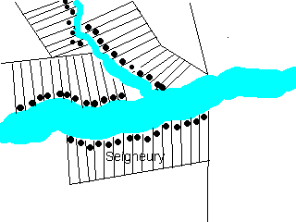
    - The Can. Government dividing land into large squares
    - 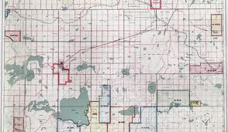
      - Metis thought their land being taken be people in East Canada
  - Americans wanted Can. prairie land
    - John A. McDonald wanted to settle and secure the land
      - convinced Hudson’s bay to sell “Rupert’s Land” to Canada
      - 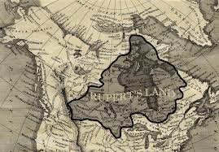
      - wasn’t thinking about needs of Metis and First Nations
        - didn’t talk to them so surveyors were a big surprise/threat
          - led to conflict
- Arrival of the “King”
  - William McDougall – McDonald made him lieutenant Governor (“King of the West”)
    - work out of the Red River Settlement (RRS)
    - Metis there threatened him
  - Louis Riel forms the “Metis National Committee”
    - made demands to McDougall to preserve their rights
    - said he couldn’t come into RRS
      - McDougall went to Hudson’s bay
      - 50 Metis came and said ‘go away’
- Resistance – Metis and Anglophones fight over land
  - Riel’s men took over Upper Fort Garry (LFG)
    - guns there for them instead of for Eastern Can.’s
  - proclamation
    - invited Eng. and Fr. speakers to join together to defend
  - McDougall comes back to Canada
    - read’s proclamation of his own
      - ‘Rupert’s Land is now part of Can.’
      - It was a faked document
  - Colonel John Dennis
    - getting Anglophones to settle the land
  - John Schultz
    - wants to fight for the land too
    - Riel stops him (for now), arrests some of Schultz’ men and makes a provisional government
      - invites francophones and Anglophones
        - read the list of rights on page 27
- Confrontation
  - Shultz men in jail and Thomas Scott is making trouble
    - read the ‘confrontation’ section on page 28
  - Riel’s men convince him to hang Scott for treason
- A new province
  - John A MacDonald invites Riel’s government to talk
    - agree to make Manitoba
      - The Manitoba Act created on May 12, 1870
  - Meanwhile Schultz is stirring up trouble for Metis
    - MacDonald send 1100 troops to “help” Metis (not really)
      - Riel didn’t ran to U.S.
      - the troops looted and beat up metis along their way west
- After the resistance
  - Riel is a wanted man for Scott’s death but he is made an MP for MB
- way of life changes for metis
  - land survey and proof of ownership concerns

