Canada in 1867 – Notes on Pages 12-21

- Read the first two paragraphs together
- observe the map of Pre-Canada in 1865
- 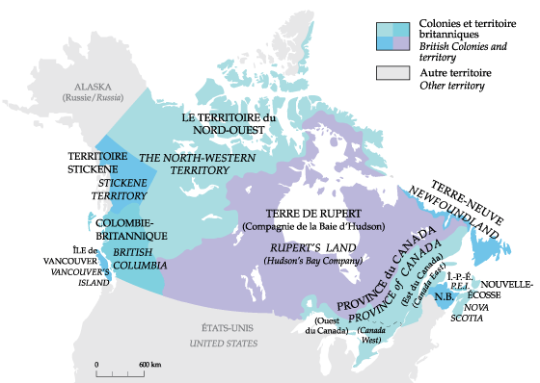
- Confederation: the process of uniting Canada
  - 3 territories unite
    - Nova Scotia
    - New Brunswick
    - The Province of Canada
      - divided in Ontario and Quebec right after confederation
  - first Prime Minister
    - John A. MacDonald
  - British Columbia was far to the west and not part yet.
- Confed was not popular
  - NS and NB wanted to unite without the Prov. of Can.
- Why confederation?
  - the British wanted colonies to be responsible for themselves
  - The American Civil War
    - Brit. helped the South
    - North won
    - British want to unite colonies for defense (in case America attacks) fin for friday
  - build strong economy
    - sell to each other and profit
      - build railway all the way to BC
- a new country
  - big area (larger than Eng. and Fra. combined)
  - only 3.5 million (Eng = 30 mill., Fra.=40 mill, U.S. = 40 mill.)
  - Canada was diverse
    - British, French, Irish, German, African, Aboriginal
- everyday life during confederation
  - no electricity or cars
  - most live on farms
    - wheat, fish, timber
  - cities were size of towns
  - roads are dirt
  - lots of illness
    - 2 out of 5 infants die of diseases
- times are changing
  - industrialization - The process in which a society or country (or world) transforms itself from a primarily agricultural society into one based on the manufacturing of goods and services.
  - cities growing
  - railways growing
  - telegraph, canals and rails connect the country
  - read going to school in the 1860s on page 14
- citizenship
  - Can. citizens considered “subjects” of the British crown
    - only 20% of pop. allowed to vote.
      - only landowners vote
      - no women allowed
      - Aboriginal and Asian people not allowed to vote
      - only the rich vote so they run the country
      - voting is public
        - gangs threatened voters
    - by begin of 20th century…
      - secret ballots
      - non-landowners can vote
- women in 1860s
  - most Canadians agreed women’s place was in the home to raise families
    - no university or jobs
    - money is for men
    - equal rights is “dangerous”
  - some women want more
    - Eliza Richie – professor in Halifax
      - was a suffragette (activist for women’s rights)
    - Henrietta Louise Edwards
      - promoted work for women
- Government in Canada
  - Canada wants strong government
    - avoid a civil war like the Americans
  - British North America Act - 1867
    - Can. is now self-governing
    - federalism – there is a national and a provincial gov’t system
      - federal/national gov’t – in charge of…
        - national defense, trade, and tax
      - prov. gov’t – in charge of local stuff
    - like Brittains gov’t
      - Constitutional Monarchy
        - Queen rules…sort of
        - gov’t has two main houses for decisions
          - House of Commons
          - Senate
  - we have a party system
    - different political parties represent different people’s views on important matters
- Political Parties
  - Conservatives
    - John A McDonald
    - Like Tariffs – Taxes for imported goods
      - then people buy local stuff
  - Liberals
    - like Free Trade – no taxes on imports/exports
      - chealper stuff and more markets
- Free Press
  - newslpapers print what they want and question the gov’t
    - argue for “Responsible Gov’t”
- The “National Policy”
  - John A. McDonald’s attempt to unite Canada’s economy
    - 1) Protective Tariffs
      - tax imports so people buy locally
    - 2) Transcontinental Railway
      - increase trade between Canadians
    - 3) Immigration
      - settle the West and make more customers

