How to Set Up Your Blog

- First you need to log in
  - go to google.ca
  - type in Edublogs and go to the link
  - type in your user name
    - your user name is yourfirstnamewbs1
  - type in your password
    - your password is the one you provided for Mr. E
  - Go to your dashboard
  - 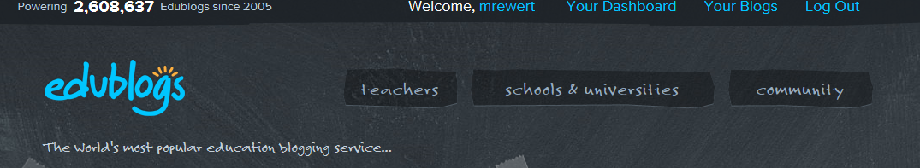
  - Go to “manage widgets and menus”
  - 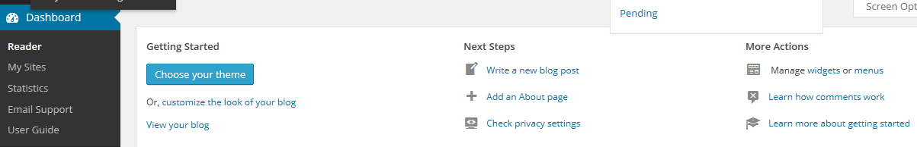
  - widgets - in your sidebars be sure to include
    - class blogs (this should be first)
    - categories
    - archives
    - recent posts
    - recent comments
    - search
  - customize your headers and backgrounds to make your blog look cool
- Now go to your tablet
  - open the app
  - it will ask you to share your url, user name, and password
    - The url is http://yournamesschoolblog.edublogs.org
    - Your user name is yournamewbs1
    - Your password is…whatever you told Mr. E to use when setting up your blog

