The Hero’s Journey
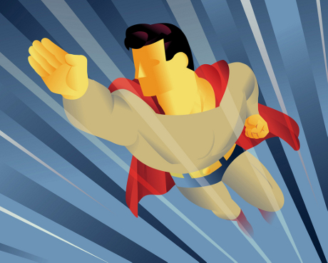
- Today we will be watching a move that follows a classic story structure of the Hero’s Journey. Your assignment will be to follow the events of the movie, take notes, and then write an argument that this movie in a classic Hero’s Journey.
- The hero’s journey is a classic story structure that you have likely seen a thousand times over. Check out the cycle shown on the back of this page. Then head to the blog for a video explaining the hero’s journey.
- See the rubric below for how you will be marked on this assignment.
Hero’s Journey Writing Assignment
 | 1 | 2 | 3 | 4
Understand the steps | The writer attempts to represent the steps but it is unclear how well they understand how the story and the hero’s journey story structure resemble each other. |  |  | The writer shows clear evidence that they understand each step in the hero’s journey. They are able to identify each of the steps of the journey within the movie.
Representing the steps in the story | The steps are unclear or cross-over at times. |  |  | Each of the steps of the journey are directly related to events in the story.
Critical understanding | The writer has not made a convincing argument. This may be due to lack of detail, unclear points, or a lack of effort in directly relating the story to the steps in the hero’s journey. |  |  | The student has included enough detail to show they have personally considered the steps of the hero’s journey and have made convincing points to argue that this story is a hero’s journey.
Total |  |  |  | /12

- 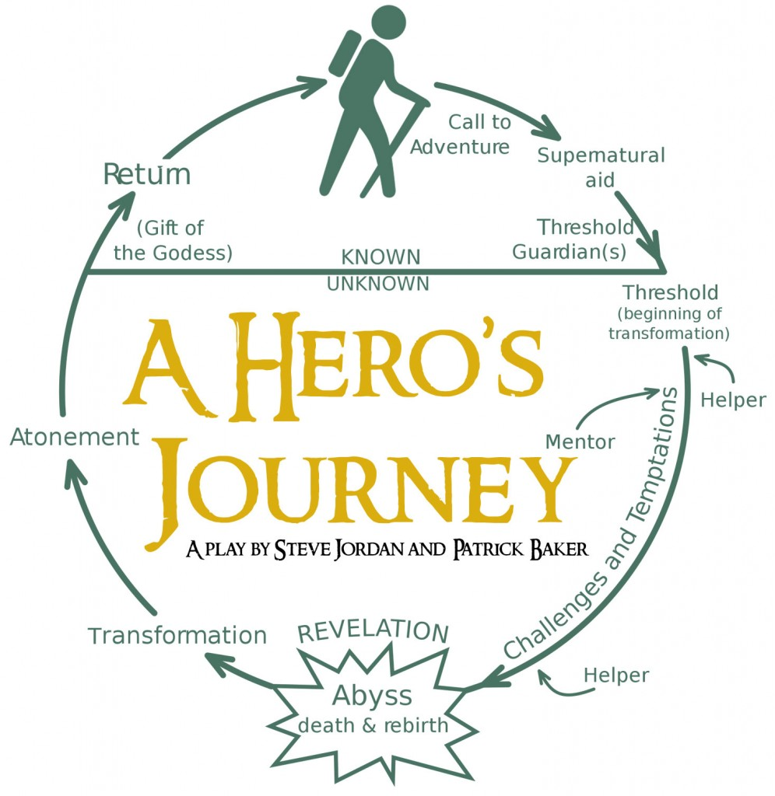

Name of Movie
Birth
The hero is both universal and unique

Destiny
The hero's destiny is revealed -- a quest is initiated. The hero may be reluctant to go.

Wise Old Man/Woman
The hero is given a charm, aid or advice by someone older or wiser.

Foes
The hero makes allies and enemies. He will be tested to prove his worth.

Romance
The hero finds romance, but this may be a hindrance or a distraction from his quest.

Final Battle
The climax of the hero's journey comes in the form of a final battle or showdown.

Journey Home
Once the hero has acheived his goal, he must return home. This journey is often difficult.

