BBC – Life – Challenges of Life – Assignment

Vocabulary:
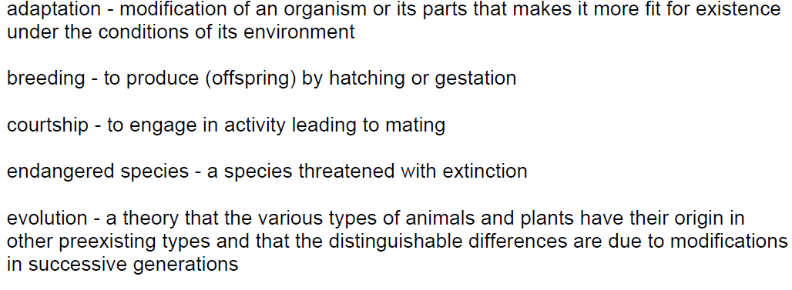
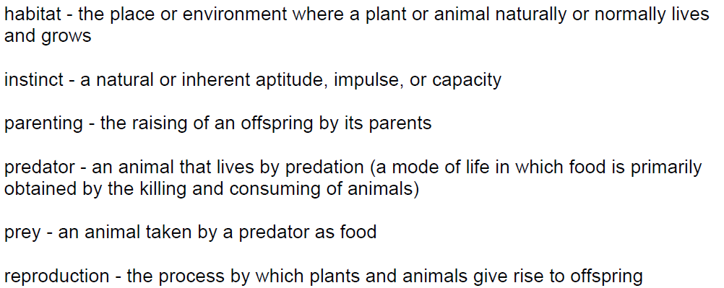

Questions (take notes in the spaces below then get a new piece of paper to answer each question in a full sentence)
1)What is the difference between a predator and a prey?

2)Explain how the Venus flytrap captures its food.

3)What does the ibex do to protect itself against the red fox? How do sardines avoid their predators?

4)How does the poison arrow frog care for its tadpoles?

5)Why do the stalk-eyed flies blow air into the stalks of their eyes?

6)How many eggs does the giant Pacific octopus produce? Why do you think they produce so many?

7)How does the capuchin monkey get its food?

How do the bottlenose dolphins work together to catch their fish in the Florida Keys? What is this called?

