Flight Lab – Using Variables to Change Flight
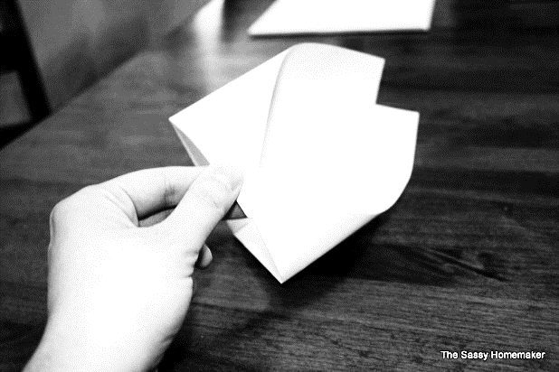
*Today we are going to make paper airplanes and see how to make them fly as far as possible. To do this we are going to make a tube plane like the one shown on the web link below.
http://thesassyhomemaker.com/2010/02/17/how-to-make-a-paper-airplane-that-actually-flies/
*We will be using different variables to experiment to see what the prime conditions of flight are for our plan.
*We will also be using proper scientific method to complete our experiments.
- Review the lab outline your teacher has given you.
- Watch this video to see what a proper science lab should include.
  - https://www.youtube.com/watch?v=ZPT9KGfLRtI
*What will we be doing?
- You will use various sized of paper (3 sizes) to make different sizes of airplanes.
- You will also use different numbers of folds (2-3 different numbers of folds) when you make your planes to see which works the best.
  - Since you will use 3 different sizes of paper and 2-3 different creations with each size (by changing the numbers of folds), this means that you will be creating 6-9 different airplanes to test and fly.
    - 3 (# of sizes of paper) X 2 (# of folds) = 6 (different airplanes)
    - …or… 3 (# of sizes of paper) X 3 (# of folds) = 9 (different airplanes)
  - Each different plane represents a change of one variable (a single change in an experiment that is tested individually.
- Each time you create an airplane you will have a tester to stand on top of a chair, hold the plane above their head and release
  - Note: it must always be the same tester because if you change who the tester is then it will change the flight of the airplane.
- With each experiment you will measure how far the plane flies from the base of the chair to the end landing point of the plane.
  - These results are all measured and recorded to create a graph later in the lab.
- Also; after each experiment you will record what variable you are changing and what you think the results may be in the next experiment when you test the changes you have made.
- After you have tested all 6-9 different airplanes you will take all your results and graph them on the graph paper provided. Once you have graphed them you will write a final summary of your lab that explains the results (measurements) of your lab.

